The Maternal Infant Health Visitor Outreach Program (MIHOW): Final Report of a Multi-Year, Multi-Site, Mixed-Methods Randomized Control Trial Evaluation Study

Senior Research Staff (all are faculty members at Marshall University):
Marty Amerikaner, Ph. D. Principal Investigator
Linda Spatig, Ed. D. Qualitative Research Director
Christopher LeGrow, Ph. D.
Stephen O’Keefe, Ph. D.

Project Researchers:
Dr. Debra Conner-Lockwood
Dr. Amy Knell Carlson
Kathy Bialk
Kelli Kerbawy
Melissa Colagrosso

January, 2016

Executive Summary
The report which follows summarizes a multiyear mixed methods randomized control trial (RCT) sponsored by the West Virginia Department of Health and Human Resources (DHHR), through the Office of Maternal, Child and Family Health (OMCFH). The study evaluated the Maternal Infant Health Outreach Worker (MIHOW) program’s effectiveness at achieving key programmatic outcome goals. Using both qualitative and quantitative methodologies, we studied MIHOW at two sites in southern WV where MIHOW had been a well-established program for many years.
The initial part of the report provides background for the study, describes the development of our research plan, and process and discusses research questions and methods. Following this is a thorough report on the qualitative component of the evaluation, followed by our presentation of the quantitative results emerging from the RCT. The last section of the report is a discussion of the results in which we attempt to provide context for our findings, use elements of the qualitative results to offer ideas about several of the quantitative findings, and suggest several perspectives from which to consider the overall results of this extensive study, including a more extensive discussion of birthweight data than was presented in the results section.
The evaluation process faced challenges tied to lower than anticipated enrollment in the study and then attrition that decreased our number of participants at later time periods quite substantially. However, our randomization process at the outset of the RCT worked well at establishing equivalent groups, and they remained substantially equivalent even as attrition decreased the number of research participants.
Both components—qualitative and quantitative—of the evaluation produced mixed findings in terms of program effectiveness. The qualitative component revealed and explored several important themes that describe key experiences of program participation, most of which are positive and clearly in line with MIHOW’s philosophy and program goals, although several important challenges also emerged. These themes include an emphasis on MIHOW’s strengths-based approach to working with mothers; a clear focus on learning (tied to the experiences of both mothers and home visitors); simultaneous uniformity (with a standard curriculum) and customization to meet individual needs; an emphasis on connecting or strong relationship bonds between home visitors and mothers and within the MIHOW program staff itself; and recognition of unmet needs and associated challenges including access and continuity of visits, economic roadblocks, and stressors associated with the RCT design of the evaluation process.
The quantitative approach, focused on the RCT, provided partial support for MIHOW effectiveness on one of its program goals related to maternal smoking, and weaker, though still somewhat encouraging support for its efforts at promoting sustained breastfeeding. There was some support for MIHOW’s positive impact in the area of decreasing the proportion of low birthweight babies though the support on this variable is somewhat tenuous.
There was no support found within the quantitative data for hypotheses concerning MIHOW’s effectiveness regarding the other program identified goals we studied, which included maternal

post-partum depression, knowledge of infant development, creating developmentally appropriate environments for infants, experiencing parenting stress, and utilization of community resources.
As noted above, our discussion section focuses on ways to understand the mixed, and – from MIHOW’s program perspective—somewhat disappointing results, particularly on quantitative variables assessed via the RCT. Issues associated with sample size, attrition and approaches to assessing key variables are discussed in terms of trying to understand both the weaker than expected support for MIHOW within the quantitative results and several apparent contradictions or inconsistencies between qualitative and quantitative findings regarding the learning experienced by MIHOW participants.
Due to our lengthy enrollment period, which was extended in an attempt to increase our number of RCT participants, the number of participants who had reached the last data collection time period of 18 months post birth as of the cut-off date for analysis of data for this report was quite low. Since attrition had become a significant factor in later time periods for data collection, we want to allow for as many data collection visits as possible in order to have the most complete set of data that we can. Therefore, we have extended our data collection period to mid-January. This date was too late to include resulting data in analyses for this report; instead, these data will be included in an addendum to this report which will be submitted later this spring. In the addendum, we will also present analysis and discussion of our data regarding how dosage (number, frequency and timing) of home visits, and the quality of the alliances formed between visitors and program participants may have impacted program outcomes assessed within this study. These latter two variables require data from the period through the last data collection point, and the small numbers in those cells at this point required us to postpone those analyses until data collection is as complete as possible.

Background and Need for the Study
The West Virginia Department of Health and Human Resources (DHHR), through the Office of Maternal, Child and Family Health (OMCFH), provides several in-home visitation programs to assist and support pregnant women. These programs are offered throughout the state, and are seen by the OMCFH as key elements in their effort to improve the health and developmental outcomes for infants and young children in West Virginia. One of the programs with an extensive track record in WV is the Maternal Infant Health Outreach Worker (MIHOW) program, which has been offered in the state dating back to 1983. Developed and still centered at Vanderbilt University, the MIHOW website offers the following brief description of its purpose: “MIHOW is a home visiting program for pregnant women and young families. Trained mothers visit young mothers in their own neighborhoods, teaching them and mentoring them about pregnancy, delivery, breastfeeding, positive parenting, nutrition, etc.”
In recent years, the federal government has moved to require valid program evaluations as a condition of continued funding for programs that receive federal support. More specifically, the U.S. Department of Health and Human Services initiated a program known as Home Visiting Evidence of Effectiveness (HomVEE), which is described on their website in this way:
The Department of Health and Human Services launched Home Visiting Evidence of Effectiveness (HomVEE) to conduct a thorough and transparent review of the home visiting research literature and provide an assessment of the evidence of effectiveness for home visiting program models that target families with pregnant women and children from birth to age 5.
HomVEE has established criteria for evaluating the quality of program evaluations and requires that programs demonstrate their effectiveness through what they call “high quality” program evaluations. The “gold standard” for program evaluations is called a “randomized control trial” (RCT) design; as will be discussed below, RCTs are the best designs for demonstrating effectiveness, but they are difficult, expensive, and raise several practical and ethical concerns. The MIHOW program, though it has decades of data supporting its value in the lives of the families with which it has worked and the communities in which it operates, has never been the focus of an RCT or other “high quality” program evaluation study, and thus the WVDHHR concluded that it was important to conduct such a study now, in a manner consistent with HomVEE criteria.
Development of the Evaluation Plan and Process
In Spring, 2011 the OMFHC sought proposals for a program evaluation of the MIHOW program. The evaluation was expected to be a three-year process, and was intended to be thorough and rigorous, producing data that would be acceptable to outside observers and funders in terms of demonstrating a valid examination of MIHOW’s effectiveness in achieving its stated goals. Our team of faculty at Marshall University put together a proposal, and we were ultimately asked to conduct the evaluation.
One of the first tasks we faced as researchers was to decide upon both an approach to the evaluation process and a design for the project. We decided early on that it was important to work as collaboratively as possible with MIHOW staff and with OMFHC in terms of clarifying goals, methods, and procedures for conducting the evaluation, believing that this collaborative approach would be the most helpful in terms of a) understanding the goals and the methods of the MIHOW program, b) establishing norms of mutual respect and open communication, and c) achieving the “buy-in” by program staff that is crucial to building the trust and cooperation that is critical to a process that will continue over a multi-year period. One aspect of the project that was clarified through these open discussions was a commitment to utilizing a mixed-methods approach employing both quantitative and qualitative strategies. Further, through extended discussions about resources, ethical issues, and the overall goals for the evaluation project, all parties (OMFHC, MIHOW leadership and our research group) agreed that the project would include a strong qualitative component, and that the quantitative design would be an RCT conducted at two active MIHOW program sites in southern WV that have been offering MIHOW for many years.
Throughout the summer and fall of 2011, the evaluation research team met via phone and in-person conferences and email exchanges to develop, review, and refine the mixed-methods/RCT plan. In late fall, the draft plan was submitted to Lance Till, at Bell and Associates, whose group is a partner within the Design Options for Home Visiting Evaluations (DOHVE) program funded by U. S. DHHS to serve as consultants regarding evaluations of home visitation programs such as MIHOW. Discussions and written communication with Mr. Till and his team resulted in clarifications of their criteria and valuable suggestions for improvement of the design, choice of instruments, and data analysis plan.
The Evaluation Plan
Both the full evaluation plan and its associated logic model were submitted and reviewed prior to beginning the project, and were attached as an appendix to our first annual report. A summary is presented below.
As noted above, the evaluation was designed as a “mixed-methods” process including both quantitative and qualitative dimensions to the data we collected and the analyses performed.
Evaluation Overview:
- Data were collected through the programs offered at two current MIHOW sites: ABLE Families Inc. in Mingo County and New River Health Association in Fayette County.
- The evaluation was initially funded for three years. However, due to the time invested in planning the project, as well as the slower than expected process of recruiting project participants, project funding was ultimately extended for an additional year.
- The initial goal was to include a total of 400 participants in the RCT; the intended distribution was 200 “full intervention” (MIHOW program) and 200 “minimal intervention” (control) participants. Because New River is a significantly larger organization, we anticipated from the outset that more of our participants would emerge from the New River service area than from ABLE Families. As we detail below, this target proved to be overly optimistic, and the final number of enrollees as of our final cut-off date for new participants was significantly smaller than the target.
- Prior to initiating the evaluation research program, our detailed evaluation plan was reviewed and approved by the Marshall University Institutional Review Board (IRB). The IRB conducted required re-evaluations of the research protocol (which was re-approved each time) on an annual basis.
- For the duration of the evaluation project, all women who sought services from either site were provided with an explanation of the project, and asked if they were willing to participate. Those who agreed were provided with and asked to sign an informed consent document (which was read to them if any reading difficulties were suspected or encountered). They were then randomly assigned to one of the two groups, based on a random assignment program developed by the research team.
- Upon enrollment in the evaluation program, women randomly assigned to the MIHOW group were worked with as regular MIHOW program participants at the site they were associated with. Women in the “minimal intervention”/comparison condition were to receive regular educational materials in the mail but no contact from the MIHOW program staff. The OMFHC volunteered to manage the monthly mailings of these materials, in that they already had access to developmentally oriented material that was available for mailing and they had staff who could organize and oversee the mailing schedule. However, due to a variety of staffing and organizational difficulties, it proved impossible to fully and reliably manage these mailings in the manner planned for the RCT. Thus, we concluded that it was best to consider the comparison group a true “control group” which received no systematic intervention of any kind, rather than the “minimal intervention” group receiving written educational materials on a monthly basis that we originally envisioned.
- All participants were contacted by our data collectors on a specific time schedule to arrange for scheduled evaluation data collection. To encourage and reward ongoing participation in the data collection process, all women received small “thank you” gifts as they participated in data collection contacts. Initially, our plan called for these thank-you gifts to be parenting related such as packets of diapers. Rather quickly this became complex and ultimately unworkable, and we switched over to small (e.g. $10) Wal Mart gift cards. These cards were provided to participants at the conclusion of all quantitative and qualitative data collection contacts.
- To collect the quantitative data for this evaluation, data collectors were hired to work as part of the research team. The women hired for this role were knowledgeable about the local communities in which data were collected, and had professional knowledge about the issues and variables of interest in the evaluation project; none had any involvement or affiliation with the MIHOW program. For the New River site, one woman did all of the data collection throughout the project. At the ABLE Families site, we encountered personnel related issues with the first two women hired to collect data. The first data collector worked for approximately 1.5 years on the project whereas the woman hired to replace her left the job after an additional year had passed. For the last six months of the project, the woman who collected data at New River extended her work to include the ABLE Families participants. This proved manageable because by then there were relatively few remaining participants who had not yet completed the final data collection.
- In all circumstances, quantitative data collectors remained “blind” to the group assignment of research participants; that is, they did not know and did not ask whether participants were in the full treatment or control groups.
- There were specified quantitative data collection points for each participant. These included: a) at enrollment; b) one month post birth of the baby; c) at six months after the birth of the baby, d) at one year after birth, and e) at 18 months after birth.

- Through discussion with MIHOW leadership and program staff, we determined that there were several key variables that the program intends to have a clear impact upon; these were chosen as the outcome variables of interest for the quantitative aspects of the evaluation. Based on further discussions, review of literature and consultations, we then identified measures for each of the outcome variables.
The targeted outcome variables were as follows:
a. Birth weight of infants: assessed through WV Birth Score and through self-report data collected from mothers;
b. Use of tobacco products during and after pregnancy: assessed through WV Birth Score and through a self-report data collected from mothers;
c. Post-partum maternal well-being: assessed via the Edinburg Postnatal Depression Screen;
d. Maternal plans for and utilization of breastfeeding: assessed through WV Birth Score and a self-report questionnaire;
e. Knowledge of infant/child development and practices: assessed by the Knowledge of Infant Development Inventory (KIDI);
f. Quality of the developmental/parenting environment: assessed using the Home Observation for Measurement of the Environment Inventory (3rd ed; Infant/Toddler version— HOME);
g. Level of stress experienced by mothers through the first 18 months of their babies’ development: assessed using the Parenting Stress Index (PSI);
f. Family engagement in developmentally oriented community activities: assessed utilizing a locally created list of community resources that participants completed through a simple “yes/no” checklist indicating utilization of the specified community resource.
- The qualitative dimension of the project was based upon different questions and thus utilized a different approach following a different schedule. The primary goal of the qualitative component was to help us understand the experiences and perceptions of program participants and staff. The process focused entirely on the MIHOW program (rather than any comparison with the control group), and involved a series of semi-structured, ethnographic interviews. Research assistants (not the quantitative data collectors discussed above) who are trained in this method and supervised by a senior qualitative evaluation researcher used purposeful sampling to select “information rich” program participants to study; interviewees included program recipients, home visitation staff and program administrators. Interviews and observations began approximately three months after initiation of the research, and were then spaced throughout the three-plus year evaluation process. In addition, periodic observations of program activities including home visitations, staff training, and staff meetings were conducted. Interview and observation data were analyzed to help understand the experiences of program participants and program staff and used to offer formative feedback to the program throughout the evaluation period.

Evaluation Research Questions

As was noted above, MIHOW is an in-home visitation program through which trained community members assist pregnant women as they prepare for childbirth and parenting. While the program’s overarching goal is to facilitate improved overall developmental outcomes for the infants, the quantitative component of the current evaluation project needed to focus on a limited number of measureable outcomes. Our research team consulted with senior MIHOW staff in order to choose variables and measures that would appropriately represent the outcome goals of the program. These included behavioral, cognitive, emotional, home environmental, and social/community dimensions of interest.

The mixed-methods research design allowed us to examine the potential contributions of MIHOW to desirable outcomes in several ways. First, the qualitative component allowed for in depth exploration of the experiences of young women participating in the program over the full time frame of the project, as well those of MIHOW staff; further, qualitative methodology allowed for careful in-vivo observation of various aspects of the program, such as training programs for staff. The resulting data—discussed fully in the qualitative section of the report below—provide rich context for understanding the lived experiences of program participants and, to a lesser extent, program staff.

On the quantitative side, our design allowed for two distinct but related approaches to exploring the potential benefits of MIHOW. The RCT design allowed us to explore the impact of the MIHOW program by comparing scores for program participants (the treatment group) to those of the control group on all outcome variables. Through the randomization process, a good faith effort was made to create treatment and control groups that are equivalent on key demographic variables (e.g. education, SES); the success of that effort was evaluated through careful analysis of those demographic variables (see discussion of data analyses below). The basic RCT research questions were whether MIHOW participants demonstrated better outcomes than controls on the following variables: use of tobacco, birth weight of babies, post-partum maternal well-being, use of breast feeding, knowledge about infant/child development, quality of home environment for child development, parenting stress and more frequent family engagement with appropriate community resources and activities. Given that MIHOW’s work is intended to produce positive results on these variables, and they report (http://www.mihow.org/about/impact.php) data from several sources that is suggestive of positive outcomes, we frame our research questions in the form of directional hypotheses, such that for each outcome variable studied in the RCT, our working hypothesis was that compared to control group members, MIHOW participants will:
- Give birth to fewer babies with low birth weight;
- Demonstrate less smoking by mothers and less smoking within their homes at the one month data collection period;
- Report greater frequency of and more extended breastfeeding;
- Exhibit less post-partum depression;
- Demonstrate greater knowledge of infant development on a standardized measure;
- Have home environments that are more supportive of infant and toddler development;
- Report less parenting stress;
- Report having had more frequent engagement with community resources.

The second approach to examining possible linkage between MIHOW and the outcome variables is through examining variation within the MIHOW treatment group that may be associated with variation in the outcomes of interest. We chose two such variables to study; the results of this part of our study will be presented in an addendum to this report to be completed this spring.
The first of these variables is a “dosage” effect, while the second, which was added after the first year of the study, focuses on the nature and strength of the relationship—known as the “alliance”—between the participant and her home visitor (as experienced by the participant).
We recognized that a number of factors would influence the extent to which specific mothers engage with the MIHOW program and the number of MIHOW program visits they would receive. For a variety of reasons, some women would be more or less consistent in meeting with their MIHOW program provider. Some will drop out while some will cancel appointments more frequently than others. Other factors, such as weather related impediments to scheduled meetings, relocation without sharing contact information, cancellation of phone service, acquiring or losing a job may also contribute to variation in dosage. The design allows us to not only compare treatment versus control group outcomes, but also to examine relationships between the “dosage”- that is, the amount of the overall MIHOW program that participants receive- and their outcomes.

The alliance concept has been demonstrated to be important to outcomes in a variety of human service fields, perhaps most notably within psychological counseling and psychotherapy, with a variety of positive outcomes having been shown to be correlated with the strength of the alliance. Early qualitative data from this study suggested that the strength of the relationship between the home visitors and their MIHOW participants was a critical component related to the participants’ engagement in the program and their perceptions of its value to their growth and learning.
Thus it seemed plausible to us that variation in MIHOW program outcomes might be linked in a systematic way to how strong an alliance is formed between program participants and their staff home visitors.
Examination of how the quantitative dosage and alliance data predict MIHOW outcomes will be correlational in nature. Along with related qualitative data that emerged throughout the study, these analyses will be intended to help us understand the results of the RCT more fully and perhaps raise questions for additional research. However, as noted above, these analyses will not be included in the current report; rather, they will be conducted and reported upon in the addendum to this report that will be forthcoming in the spring of 2016.

Qualitative Research Report

At the outset of planning for this evaluation project, the funders—OMCFH—made it clear that they wanted a qualitative component to the study, thus bringing to the forefront the value they place on the insights and other results achieved through this approach. Thus, immediately below is the report submitted by the qualitative research “team” which was led by Dr. Linda Spatig, an experienced qualitative researcher and teacher. This report is presented as a whole, rather than tied to sections of the quantitative results, for two reasons. First and foremost, qualitative methodology, and the assumptions which underlie it, are significantly different than those for more quantitative approaches, and thus the questions asked and the approach to understanding the phenomenon of interest (in this case, the MIHOW program) do not neatly track the pre-established research questions and/or hypotheses which guide an RCT. Second, taken as whole, the qualitative report provides an important context for understanding the overall MIHOW program as experienced by its participants and staff. Given that qualitative researchers frequently “follow the data where it leads,” the results can clarify, generate insights about, and provoke important questions about the quantitative results which immediately follow this section.

Purpose
The purpose of the qualitative component of the West Virginia MIHOW research was to understand how the program is experienced and perceived by people who are involved in it on a day-to-day basis—namely participating families and MIHOW staff. The goals were to provide information and insights that would be helpful in explaining quantitative findings and helpful to program designers and implementers in efforts to make the program as effective as possible.
Research Team
During the fourth year of the study, the qualitative research team consisted of the same four research assistants involved in years two and three. Research assistants were doctoral students in education, each of whom made some aspect of the WV MIHOW program a focus of her dissertation research. Dr. Debra Conner-Lockwood successfully defended her dissertation research—focusing on how MIHOW participants (moms and home visitors) understand the program’s influence on child development—in June, 2015. Dr. Amy Knell Carlson successfully defended her dissertation research—focused on the training and work experiences of MIHOW’s paraprofessional home visitors—in early December, 2015. Kathy Bialk’s dissertation, focused on how MIHOW’s strength-based approach is understood by participating moms and MIHOW staff, including those in top leadership positions, and Kelli Kerbawy’s dissertation, focused on MIHOW as a community-based adult learning program, are in progress.
As was true in prior years of the study, research assistants worked under the direction of Dr. Linda Spatig, a doctoral-level qualitative researcher and professor in the College of Education and Professional Development at Marshall University with extensive experience in evaluation research with community-based programs. During the fourth year of the study, the team continued to meet regularly to discuss new data, especially in relation to how the data did, or did not, correspond with those generated in prior years of the study. We also used meetings to plan upcoming data collection.
Participants
Over the course of the four-year study, we conducted 66 individual interviews with participants including mothers, home visitors, and other MIHOW staff members. Of the 66, 39 were conducted with individuals affiliated with the New River site, 25 with individuals affiliated with ABLE Families, and two who were affiliated with both sites. Most participants were interviewed two to four times each; 16 were interviewed one time only.
During year four of the study we conducted 27 individual interviews with participants including mothers, home visitors, and individuals in consultation and leadership positions with the program. Of the 27, ten were conducted with participants in the ABLE Families MIHOW program, 15 were with participants in the New River MIHOW program, and two were with individuals affiliated with both programs. We also conducted a focus-group interview with MIHOW staff, and conducted participant observations of parts of two MIHOW conferences, a MIHOW staff meeting, and two home visits.
As in earlier years of the study, we sometimes had difficulty this past year reaching mothers for interviews, encountering disconnected phone numbers, leaving messages that received no response, and scheduling interviews for which moms were not actually available. MIHOW staff continued to assist us by providing updated contact information for participants. We had no problem reaching home visitors or other MIHOW staff and scheduling observations and interviews with them.
Data Collection and Analysis
As was true in the first three years of the study, most data were generated from individual phone interviews conducted by the qualitative research assistants. The focus-group interview was conducted face-to-face in conjunction with an observation of a staff meeting. Also, on two occasions, observational data were collected at MIHOW conferences and on two occasions, at home visits.
Initial interviews focused on how mothers came to be involved with MIHOW; in what ways their experiences with the program did—or did not—match their prior expectations of it; their perceptions of home visits; their relationships with other program participants (other mothers and/or home visitors); concerns about pregnancy, childbirth, or parenting; and perceptions of program strengths and shortcomings. Second interviews with mothers focused on their experiences with childbirth; how the new baby was doing; and how MIHOW has—or has not—influenced them or their families. Third interviews focused on how the child was developing; how the mother was feeling; what and how mothers had learned about child development, parenting, their communities, and their own strengths; mothers’ goals and aspirations for the future for themselves and their children; and their overall reflections on their experiences with MIHOW.
Interviews with home visitors and other MIHOW staff (e.g., consultants, supervisors, directors) also focused on their experiences with the program. Several staff members had been in a variety of roles with the program, some starting as mothers, becoming home visitors, and then moving into supervisory positions. We asked about their perceptions of the program’s mission, the training for home visitors, and its influence on child development. We also talked with them about the program’s strength-based approach and the experience of working for the program generally.
Interviews were transcribed verbatim and transcripts were disseminated to all qualitative research team members. As a first level of analysis, each research assistant individually reviewed transcripts of interviews she conducted, adding reflective and analytical comments. Comments summarized key points from the interview, identified new information that emerged in the interview, and provided insights about how the interview extended our prior understandings of participants’ experiences and perceptions of the program.
Each team member reviewed all interview and observation data documents and discussed them in team meetings. Later, each research assistant coded data that were relevant to her particular research focus, using coding categories agreed upon with the team, as well as any others she believed to be important.
Strengths and Limitations
By following individuals over a four-year period, we developed substantial rapport with participants, enabling us to explore issues in greater depth than we would have been able to do in a study of shorter duration. The extended fieldwork, as well as the ability to use data collection tools that are semi-structured (both uniform and customized), enhanced our ability to accurately understand the program and what it means to those involved. In other words, our confidence in the internal validity of our findings, their accuracy for the mothers and MIHOW staff we studied, is strong.
On the other hand, our findings, presented in the form of emergent themes, may be true only for those in the two West Virginia MIHOW sites that were part of this research. They cannot be generalized, in a statistical sense, to other people and programs, even those related to MIHOW. That said, we believe the findings have practical, and perhaps theoretical, implications that go beyond our sample.
Findings
The first qualitative report, based on initial interviews with three mothers and two home visitors, identified three emerging themes: (1) that the program is both uniform (with a standard home visitation curriculum) and customized (to meet particular family circumstances) at the same time; (2) that the program features connections—with community organizations and resources, with people, with families; and (3) that the program involves considerable learning on the part of mothers (and other family members) and home visitors.
Year-two findings extended these initial understandings. In the second annual report we revisited year-one themes, discussing (1) how the program might not be as customized as some participants would like; (2) how mothers were learning what to expect about pregnancy, childbirth, and child development and learning how to play with their babies in new ways; and (3) how the strong, positive relationships between mothers and home visitors may be a critical ingredient in the quantity and quality of what mothers gain from the program. The second year report also included a new theme—the way the program was empowering for mothers.
Third-year findings built on those prior findings, discussing what we learned that year about how the program provided simultaneously uniform and customized services, facilitated learning, forged connections between individuals and within communities, and recognized participants’ strengths in empowering ways. In addition, a new theme was discussed—perceived needs the program had not met. Some unmet needs were related to conditions the program may not be designed to address. Others seemed to be a result of unevenness in program implementation, with some mothers not receiving regular monthly visits.
Our fourth and final report revisits, once again, findings from prior years. For each theme, we discuss observation and interview data from year four, clarifying how, and to what degree, our understanding of the theme deepened over time. What is different in this final report is that we begin with an umbrella theme, related to the program’s strength-based approach that seems to be a thread running through all other themes. After a brief introduction, the findings section of the report addresses how MIHOW’s strength-based approach is both uniform and customized; what and how staff and mothers learn about and from the strength-based approach; how the focus on strengths enhances relationships among participants; and how, despite obstacles of several types, it empowers participants, communities, and even the program itself. In this final section, we also examine themes in relation to each other, and as a group, synthesizing them in order to identify over-arching ideas that may be relevant to quantitative findings or be helpful to practitioners.

The “Magic of MIHOW”: “It’s all about the Strengths”
We began hearing, mainly from MIHOW staff, about the program’s strength-based approach at the end of the second year of the research. In last year’s report, we wrote, as part of the Empowerment theme, about mothers feeling “more in tune with themselves and their own strengths” and beginning to “view themselves as more informed, capable, and confident than they had been prior to the program.”
It was not until year four of the study that we realized just how pervasive and central the strength-based focus is, to virtually every aspect of the program. The MIHOW website, at Vanderbilt University, notes that in order to accomplish its mission—“To improve health and child development for low-income families”—the program “uses a strength-based approach . . . recognizing that regardless of working or living conditions, every family, organization, and community has strengths. Helping the MIHOW staff and participants build on these strengths is the fuel that drives each MIHOW program.”
It is one thing to articulate a strength-based approach in program materials, but it is another matter to actually implement such an approach in the program on a day-to-day basis. Our year-four data suggest that WV MIHOW has been successful in accomplishing that, especially with program staff. Home visitors and other MIHOW staff we interviewed saw the strength-based focus as MIHOW’s most important feature. One home visitor who described MIHOW as “mothers helping mothers” went on to say that the program is “all about the strengths . . . . It’s all a strength-based approach, which is what the program really is . . . . You build off of their [mothers’] strengths.” Another home visitor described her work as “going into the home, pointing out strengths that maybe no one has ever pointed out to them, help[ing] them use those strengths to [become] better people and . . . better parents.”
Interviews and observations with MIHOW home visitors and other staff are full of information about the program’s focus on strengths. In interviews with mothers, on the other hand, rarely did any mention of strengths occur. Mothers spoke again and again about their home visitors, describing them as valuable sources of support, of assistance of many kinds, and information. They spoke of their home visitors as companions, friends, even likening them to sisters. They also described many kinds of activities they did with their home visitors including milestone checklists, activities with the child, and so on. What mothers did not talk about was the home visitor pointing out strengths or things they did well. Perhaps this is because home visitors do not explicitly use the word “strengths” as part of their conversations with mothers. Or perhaps mothers are uncomfortable speaking with people with whom they are not very close (qualitative research assistants) about their strengths. They may feel that doing so would be arrogant or self-aggrandizing.
Customizing a Strength-based Approach
Early in the study, we became aware that MIHOW is simultaneously uniform, following MIHOW’s year-by-year home visitation curriculum, but at the same time is customized or varied to meet the needs of individuals and families. Ironically, the fact that the program is routinely personalized for mothers and families was uniformly evident in our data throughout the four-year study. Other than a few cases when mothers were not receiving regular visits, we are not aware of any instance where the program did not at least try to respond to a mother or family’s needs, regardless of the extent to which those were directly related to childbirth, parenting, or child development.
Again this year we observed an emphasis on customizing services for mothers and families. Based on interviews with home visitors and observations of home visitor training, it seems that home visitors are encouraged to prioritize the family’s needs over their own plans for a visit. One home visitor explained, “We have these curriculum guides that kind of guide us through the information that we need to cover, but I like to go in there [the home] and see what [the parents] know because I’m a teacher at heart. I don’t want to reteach if someone already knows things.”
Whereas the way the curriculum is used varied depending on circumstances, the focus on strengths was uniform in the program. Without exception, every MIHOW staff member with whom we spoke emphasized the importance of a strength-based approach and provided details about how they learned it, how they applied it in their work with the program, and how it influenced them personally—at work and beyond.
As noted above, the focus on strengths was viewed as critically important to home visitors’ work with mothers and families. We also found that it was central to the relationships among home visitors and between home visitors and their supervisors. In other words, the focus on strengths was pervasive in the program. According to one home visitor, “We have our own strengths and this job has helped me to learn some of mine. My boss has helped me to focus on what I have that helps me be a good home visitor.” She went on to say, “My strength is I will advocate for my parents. That is my own personality [to speak my mind], but the job brings out the good parts of that. I did it myself, but my boss made me realize I did it.”
Mothers, however, did not speak with us as frequently or directly, as did the home visitors, about the strength-based approach, at least not in those words. In thinking about this issue, one home visitor told us, “Often initially I think people don’t recognize their own strengths. . . . They have so many people telling them what they’re doing wrong, that they’re not even thinking that they could possibly do anything right.
When asked directly about things she was good at, one mother said, “I’m good with people and stuff like that in general, and just at home with my kids. . . . I [won’t] be shy about it.” She went on to speak with pride about her own “little business” with pictures. When asked whether her home visitor had pointed out those strengths to her, the mother described some of the compliments she received from her home visitor:
Oh yeah. . . . Every time she comes, she’s like, “I [have] seen those pictures. . . Those are fantastic.”. . . . And she always compliments on my house and things of that nature. You know, she’s like, “Your floors are pretty.” . . . She compliments my kids. . . . She’s like, “I love the way you do their hair” and just stuff like that. She’s a big complimenter.
The emphasis on strengths, for both mothers and staff, was uniform and pervasive, but the specific strengths identified in particular individuals varied widely and this was intentional. Staff members seemed to genuinely believe that all individuals and families have strengths, but they were assumed to differ in terms of which particular strengths they had.
Another way the strength-based approach seemed to be less than uniform, in an unintentional way, relates to the distinction the program makes between strengths and behaviors. One home visitor described a behavior as “anything they [mothers] do really, but a strength . . . comes from within.” She illustrated that distinction with a story about a mother with a premature baby wherein caring for the baby and keeping up with medical visits would be behaviors, but the mother’s strengths would be determination and not giving up. Another home visitor, however, in describing strengths she had identified in her mothers, mentioned “they always get their bills paid” and “they always read to their kids,” both of which would be classified as behaviors, rather than strengths, according to the first home visitor’s thinking.
Learning
We have noted a programmatic focus on learning from year one. Earlier reports detailed the kinds of things mothers were learning, especially in terms of what to expect, with pregnancy, childbirth, parenting, and child development, and in terms of how to play with their babies in new ways that promote positive, healthy development.
We also have reported on what and how home visitors were learning as they participated in program training. In the fourth year of the research, we examined the learning of mothers and home visitors in greater depth. For home visitors, we focused on their experiences with and perceptions of MIHOW training, which is extensive and varied, but uniform in its emphasis on learning about a strength-based approach. Home visitors see that as an especially important part of their initial and ongoing training. For mothers, featured in the second part of the learning theme section, we extended our prior understandings of what mothers were learning (e.g., about child development) by examining how they are learning by using developmental milestone tools to understand and assess their children’s progress.
Learning to Listen “with an Open Mind” (Home Visitors)
Because it is viewed as so central to the program’s mission, there is extensive staff training related to taking a strength-based approach. According to one home visitor, “I don’t care if you’ve worked for MIHOW for 15 years, you’re continually trained on the strength-based approach because it’s just the core of what we do.”
Home visitors talked extensively about their training on how to work in a strength-based way. They emphasized learning to be non-judgmental listeners and to identify strengths in many different kinds of situations, even those that appear to be seriously troubled. As one home visitor explained, “We have . . . trainings on ways to find strengths” in all kinds of homes. In an initial training session, we observed MIHOW home visitors being encouraged to go into each home visit with an open mind and without plans to impose their own ideas or values on the family. Instead, they were to use “active listening” strategies and be aware of non-verbal communication. Specifically, they were advised to take three steps: (1) Stop before you speak, (2) Look at the nonverbal signs, and (3) Listen to the words.
Home visitor training on taking a strength-based approach also includes them practicing on each other. An individual in a leadership position described the process:

We do training where we have people [home visitors] talk to each other about difficult times in their lives and how they manage to get through those times in their lives. And so there’s a talker and a listener. The listener has to listen for what got them through and then be able to put those things into words that are strengths, strength kind of words. And so they’re looking at strengths of relationships, and they’re looking at strengths of character, and they’re looking at like the resources. So they start just by doing that, by listening to each other and looking at those things within each other.
Home visitors seem to be getting the training messages loud and clear. In interviews, they spoke again and again about the importance of being nonjudgmental and open-minded, which was not always easy in their day-to-day work. As one home visitor reported, “That’s like a really big thing for a home visitor to go through, to lose your baggage at the door and go in and be there for that individual that you’re visiting. Likewise, another home visitor commented, “When you go to training, they teach you these roles . . . [using] these scenarios . . . and you’ve got to learn what you’re going to do in that scenario and how you’re going to handle it . . . . You’ve got to go in there with an open mind.” Home visitors are required to identify, in writing, strengths observed on every home visit they make. One home visitor described doing this with one of her MIHOW families:
I’ve gone into a house that’s infested with cockroaches. And you’ve got to . . . keep your mouth shut and figure out how to do it and say, “Thank you,” and stay positive. . . . You are not there to change them so you can’t judge. What they think is okay as long as it [doesn’t] harm the baby.
Another home visitor who talked about challenging family situations she encountered stressed that listening nonjudgmentally, while difficult, is sometimes the best thing to do. “Being quiet is sometimes the hardest thing to do, but it often can be the most important,” she explained. “I find myself saying, ‘Let’s see if I’m clear about this,’ or ‘Let’s see if I understand this correctly.’” She spoke about how this approach can be effective: “If I say what I think and don’t let them speak, then I’ve lost them. But if I listen and wait for them, I [can eventually] speak and give advice.”
In addition to using a strength-based approach, home visitors made regular and frequent use of the Ages and Stages Questionnaire, a child-development screening tool. One home visitor described the instruments as “good indicators for children that aren’t meeting their milestones.” The monthly screenings consist of six questions in five areas of development: communication, gross motor skills, fine motor, problem solving, and personal-social.
Another home visitor spoke about how she used the questionnaires to assist a mother with keeping track of the words her daughter was learning:
Mom is real worried because that baby was premature and so we watch real close and she writes down the words or sounds she hears that baby use. And she did that on her own because one time after I was filling out the Ages and Stages form with her, she couldn’t think of any words that baby was using. So next time we did one the next month, she pulled out a list. And she did that on her own because she knew I would ask again and she wanted to get it right to make sure her little baby was growing like she should.
This mother’s response to the Ages and Stages Questionnaire was not uncommon. When we spoke with moms about how they believed MIHOW did or did not influence their child’s development, their comments often focused on what they called “milestones” or “checklists.” As concrete, specific guidelines, mothers found them useful in knowing what to expect of their children, how to parent them toward the next developmental step, and how to assess their progress.
Learning about Child Development, Milestone by Milestone (Mothers)
In earlier reports, we described how mothers were learning from and with home visitors through activities such as games, exercises, and singing, as well as from materials such as children’s toys and books. We also described how mothers learned from home visitors modeling positive behaviors such as verbal interactions with the baby.
Mothers interviewed this year continued to mention these methods and materials, but also they often referred to “checklists” home visitors use to see how the baby or child is developing and to determine what the baby is able to do as well as what the baby needs to work on. Mothers spoke about how they used the checklist content in ways that went beyond the visit itself. One explained, “There’s milestone papers that she [the home visitor] gives me. I’ll read them like three times a week and get it embedded in my head and then I’ll post it.” Another mom talked about how she worked with her daughter to promote development: “[I] like to practice different exercises and get her to doing things so that [at] the next milestone meeting I can check off new things.”
Again and again, mothers referred to milestones and checklists in discussing their knowledge of child development and parenting. One talked about how they let her know “what to expect at [her son’s] age, and what to work on.” Another explained that MIHOW helped her with any health or developmental concerns, saying, “Once the baby comes, they [home visitors] keep track of developmental issues or any health problems they [the babies] may have and try to help.” She found the milestone forms particularly helpful because they “guided your way so that you’re not feeling lost as to your child’s development . . . . It gives me an idea of things to work on with her.” Likewise, another mother commented, “I like the ones [papers] about the baby’s development and like what they’re doing, what they should be doing, [and] if they’re not doing it. If you haven’t had other kids and you’re not sure about developmental stages and how kids age. . . [it] would be hard.”
Clearly, mothers in both MIHOW sites viewed the milestone checklists as valuable sources of knowledge about what to expect of their child’s growth and development, as ways of assessing and keeping track of their child’s progress, and as helpful guidance for them as parents. And there is evidence that at least some mothers played an active role in completing the questionnaires. One mother described how she and the home visitor used the checklists: “She’ll [home visitor] mark off not only what she sees but my feedback as well, what my concerns are, or if I think my baby is developing right where she needs to be or even sometimes a bit ahead.”
In and of themselves, the milestone checklists can be viewed as focused on both strengths and deficits, in child development directly, and indirectly, in parenting. The tool is designed to assess and track both what the child can and cannot do in relation to five basic areas of development. In terms of how the tools are implemented in West Virginia MIHOW, however, our observations and interviews suggest a positive, strength-oriented experience with them.
At each monthly milestone visit, home visitors, in collaboration with mothers, marked the form indicating behaviors that the child could and could not do. Depending on how a baby or child was developing, at any given visit there might be more items marked indicating the child’s strengths and accomplishments or more indicating what they could not yet do. That said, mothers were positive, even enthusiastic, about the process and the instruments themselves, and invariably discussed them in terms of their benefits. They seemed to eagerly anticipate the next “milestone visit” and, as noted above, they saw them as valuable sources of knowledge that strengthened their parenting, in turn better enabling their children to reach greatest potentials.
Connecting
An emphasis on human and community connections was evident throughout the four-year study. In prior reports, we discussed strong relationships between home visitors and mothers, likening them to, as well as distinguishing them from, family connections and close friendships. From the beginning it has been evident that both MIHOW staff and mothers value their trusting, caring relationships with each other, often naming those relationships as their favorite part of being involved in the program.
In year four we extended our knowledge of the human relationships that seem to be so critical in the program by examining how such positive and important relationships are developed and maintained. We looked at mother-home visitor relationships as well as MIHOW staff relationships with each other. In both cases, we found that MIHOW’s strength-based approach played a key role.
Connecting with Mothers: “Somebody is There for Them”
The close, strong connections between mothers and home visitors we observed throughout the four-year study are a natural outgrowth of MIHOW’s focus on strengths rather than deficits. One reason home visitors view their training to focus on strengths and take a nonjudgmental, open-minded stance to be of paramount importance has to do with the relationships between them and the mothers. As one home visitor put it, you “lose your baggage and your own stuff at the door and go in there and be there for that individual you’re visiting.”
Another home visitor also saw a direct connection between the mother-home visitor relationship and the program’s focus on strengths. Interestingly, she explained it in terms of the strong relationships enhancing the effectiveness of the strength-based approach: “I felt like my relationship with her [mother] helped to bring out that strength. Her strength was to make sure that she had a home to go to. She didn’t want to always . . . rely on her mom and dad.”
As noted in last year’s report, home visitors were not trying to be friends with mothers. Rather, as one explained, “I am there to be somebody’s listener, somebody’s advocate.” Another noted that her role as a home visitor is “to go in there and listen, observe, and help that family use their strengths that do exist in every family.” This is consistent with the program’s focus on forming strong positive relationships with mothers, as a person in a MIHOW leadership role explained:
When you go into home visits, you’ve got to think about it. We are visiting. We’re not going in just to teach a lesson. We’re going in to spend some time with mom, to give mom some good attention, to develop a connection.
In training sessions, we observed home visitors learning how to be a mother’s confidante. They were told that often a home visitor is the only individual a mother trusted enough to ask sensitive or embarrassing questions. This was why listening and assisting without judgment were seen as essential to the development of successful mother-home visitor relationships.
Developing a comfortable rapport between mothers and home visitors was important to establishing and maintaining the strong bonds between them. Our interviews and observations suggest that this rapport came easily in many cases. One home visitor reported that it was not difficult for her to gain rapport with the mothers: “They tell me everything. . . . Some of them tell me too much.” Mothers gave us similar information. One told us, “She’s [home visitor] just really friendly and easy to talk to about anything. If I feel like there’s anything that I want to talk to her about I can bring it up and not feel weird about it.”
The intense bonds in mother-home visitor pairs formed as a result of spending time together and developing comfortable rapport that featured nonjudgmental listening and a focus on strengths. According to one home visitor, those bonds often only take a few months to form: “[It’s] the third or fourth visit where they really are drawn in hook, line, and sinker.”
Connecting with other MIHOW Staff: “Somebody’s Got Your Back”
MIHOW’s strength-based approach also influences relationships among home visitors and between home visitors and supervisors as well. One home visitor referred to the group of home visitors as a “team. . . [that’s] been together for so many years.” Other home visitors concurred, speaking of the strong support they receive from each other.
The program’s focus on strengths was viewed as directly related to the close and supportive nature of the group. One home visitor explained, “Every time we meet we have a positive check-in. We do our business. We have appreciations at the end of our meetings. It’s just a lovely way to work.” We found that the positive check-ins were done at both sites, providing evidence that the program’s commitment to a strength-based approach permeates work with staff as well as with mothers. This is not lost on the home visitors, one of whom noted that hearing someone else identify your strengths “gave you a confidence, made you feel good.”
Monthly staff meetings and monthly one-on-one meetings with MIHOW Site Leaders are times when home visitors hear about their own strengths and how they can use those strengths in their work with mothers and in other parts of their lives. The one-on-one meetings with site leaders are called reflective supervision. During these sessions, site leaders use the same kind of nonjudgmental, open-minded listening that home visitors practice with mothers. This approach makes for a non-threatening, positive space where home visitors feel free to talk about their concerns, their challenges, and their triumphs. As one home visitor described it, “It’s a chance to rant and rave about what we have problems with, what’s going on, what we need help with, anything like that.”
Home visitors seemed to treasure these reflective supervision meetings. One described what they meant to her:
We all have this one-on-one thing with her [site leader] and it’s just so wonderful . . . . She’s always there for you and [is there] to help you. That’s one bonus I have with this job. . . . She does so well with helping you get to your strengths and she’ll talk to you no matter how long it takes. She’ll just be there for you.
The close, trusting relationships staff members have with each other, including with those in leadership positions, provide a highly supportive work environment. Several home visitors spoke about how their MIHOW co-workers had supported them in their personal lives. These situations included the death of a spouse and support for going back to school. One said, “When my husband died twelve years ago. . . they were there for me just on a personal level. . . . They gave me time to grieve without the pressure of jumping back to work. They helped me and my kids and let me work around my kids’ schedules since I was now a single parent.”
Home visitors, who mostly work part time with no benefits, would like to have higher wages and other resources such as access to vehicles for making home visits. That said, they spoke with deep appreciation, and in emotional and glowing terms, about the experience of working for MIHOW. In large part, that seems to be a result of the respectful, positive environment created in a program that truly walks the walk of a strength-based approach.
Empowering Despite Obstacles
Data from year four, especially when considered across themes, and examined in relation to data analyzed in the first three years of the study, provide evidence that MIHOW is an empowering program, for individuals and their families, for communities, and even for the program itself. Even so, as noted in the year-four report, unmet needs and other obstacles remain. In this section, we begin with a year-four update on unmet needs and obstacles. That update is followed by a discussion of the transformative power of this strength-based program.
Unmet Needs and Obstacles
For Mothers. Whereas at least one mother got a driver’s license and car this year, others continued to express concerns about a lack of transportation. A mother who did not own a car limited her education plans to facilities nearby: “I don’t have a vehicle, [so] I have to get a ride.” Another, whose home visitor had offered to serve as a job reference, spoke about transportation needs as a barrier to finding good employment.
At this point in my life I do not have a vehicle so transportation is a major issue. I don’t want to be unreliable because I don’t have transportation. So I did apply for a job at [nearby health facility] but they never called me. . . . I don’t have any way to do it [get a vehicle]. It’s like you have to work so you can have the income to get a vehicle, but I don’t have a way to get there unless I walk and I don’t really want to settle for second best and work somewhere like McDonald’s.
Mothers also continued to express concerns about the lack of childcare available to them. When asked about anything that would be helpful in achieving her plans for the future, one mother said, “Some kind of daycare thing. I would love to have a daycare around here. . . . That would be nice [because] then I could actually go to work.”
We also heard from mothers in year four who expressed a need for more information and assistance with guiding their child’s social-emotional development. One mother said, “I’ve been wanting to ask some questions on his [son’s] behavior and not listening to me and just straighten out his tantrums. I don’t know what to do.“ Another complained about a lack of depth of content: “It’s just kind of scratching the surface. Like I remember that last visit she [home visitor] talked about discipline and positive discipline. . . . She mentioned not hitting your child when they make you mad, but didn’t really give examples of what you could do instead of that.”
In last year’s report, in addition to transportation and childcare needs, we noted that some mothers were not receiving regular monthly home visits. In year four, we interviewed only one mother who had not received regular home visits but seems to have wanted them. She said she was referred to the program, but when asked about recent home visits, she indicated that she had regularly seen a quantitative data collector, but not a home visitor:
When you or the lady who comes and asks the questions would be like, “How’s your worker doing,” . . . I’d be, “I don’t know what you’re talking about because I haven’t seen anybody.” . . . I think she was. . . right at the time I had [the baby] or a little bit before, I guess the lady quit or something and then this lady was trying to cover a zillion counties. So I think that’s why I didn’t see anybody for so long.
She said that she did not expect to get a home visitor in the future, but when asked what she would like to get from the program in the future, she responded, “I’m always up for parenting advice. . . . I’m always up to try new things.”
For Home Visitors. In year four, we also learned about an unmet need of home visitors—professional services to help them cope with traumatic or stressful circumstances. According to one home visitor, it was the situations in which she felt powerless to help that were the worst—a family whose electricity was cut off, a family whose dog was run over, a mother whose baby will be born with a serious physical abnormality. One home visitor frankly expressed a need for assistance:
You may go into one home and they’re very unhappy. You can’t change them; you just worry about them. And then it’s just like you can’t shake it off. Are there any things out there that we can get help from for our own selves? Because there’s a lot of times I carry stuff for a long time. . . . Sometimes I just need somebody to talk to. . . I just go talk to [MIHOW supervisor] but that’s not like talking to a professional. I want somebody that can help me.
Another MIHOW staff member acknowledged that the home visitor’s job was difficult emotionally. “There are times when it can just be overwhelming. . . . because of substance abuse or . . . domestic violence or . . . terrible poverty. So being part of that with those families can take a real emotional toll.” Yet another staff member shared stories of especially difficult circumstances that are “hard for the workers [home visitors] to have to deal with.” She described experiences with drug dependent babies, a family member who “rolled over on their baby and killed it. You know that’s traumatic for that worker because she questions like could I have done something.”
In relation to this, some in MIHOW leadership positions stressed the value of reflective supervision and the importance of creating a supportive work environment for home visitors. Data from year four suggest that at least for some home visitors, such factors may not be sufficient to meet their needs.
In addition to support in dealing with the emotional toll of the work, home visitors faced obstacles related to making regular monthly home visits to some families. As mentioned above, in last year’s report we noted that a number of mothers had not received regular monthly home visits. In several cases, the irregular visitation schedule was attributed to mothers who could or would not schedule regular visits. In year four, we learned that the reason some mothers signed up for the program and then did not want to schedule visits had to do with the randomized control-treatment evaluation study. The strong push to increase the number of participants, in both treatment and control groups, affected MIHOW’s normal recruitment and enrollment processes, as one staff member explained: “[For the research], we had to recruit and recruit and recruit and recruit and just grab people and say, ‘Do you want to be a part of this?’ Whereas when we’re not doing that, we’re approaching people and really explaining the program so they get more [information] before they say yes or no.”
Likewise, a home visitor saw the research recruitment process as a deviation from the program’s normal ways of recruiting program participants, one that hurt the program’s retention rate:
In the past, MIHOW has received referrals from . . . our [community] clinic. . . . Their very, very first prenatal visit. . . . is the perfect time to talk to a prenatal patient about MIHOW. . . . When the random control trial came around it was like, “Okay, get this number of families fast.” So a lot of people were trying to get referrals. So we ended up with a lot of referrals . . . not necessarily people seeking the MIHOW program or being told about it the way they had in the past because I feel the moms that were referred in earlier years were more interested or invested as far as from day one, and I think we retained those families.
She went on to describe her own experiences with some mothers in the treatment group who continued to participate in the quantitative data collection, but chose not to receive home visits.
I could never get into the home. They didn’t want me to come. . . . I did everything humanly possible and I still never got into some of the homes. . . . They would get visited by the [quantitative] data collector. . . I would see the forms from the data collector and file them. . . I could see she was still seeing people that I had really tried to get in that were treatment but we never got to see them. They didn’t want [the program] but they wanted that gift card from the data collector.
The demands of the research design itself influenced the program’s normal operations in ways that were uncomfortable for home visitors who were in the habit of working with people who enrolled in the program because they actually wanted to participate in it. “[The research] was a new thing for us [MIHOW staff] and . . . people got in treatment that really didn’t want a home visitor and then people that really wanted a home visitor got in control. That was the hardest thing for us because we couldn’t visit them and they wanted services.”
In addition to barriers related to the research design, we learned from home visitors about other barriers they faced in meeting regularly with mothers. We heard about bad winter weather as a challenge to regular visits. Also, home visitors and other MIHOW staff identified increases in substance abuse and mental illness as barriers to visitation. According to one staff member, “The biggest challenge now I would have to say is substance abuse and mental illness. There are lots of partners that resist having a home visitor because of substance use.”
The Power of a Strength-based Program: “MIHOW Saved my Life”
Notwithstanding the concerns outlined above, for individual participants, including mothers, home visitors, and other MIHOW staff, the program’s emphasis on strengths is confidence-building, enhancing self esteem and a sense of self efficacy about what they can do and be. Over the four-year study, and especially this past year, we heard from mothers and MIHOW staff who believe they are stronger individuals, better parents, more effective paraprofessionals, and stronger community leaders because of their involvement in MIHOW.
The strength-based approach seems to be at the heart of these changes. Staff members explained: “It [focusing on strengths] builds people’s confidence . . . . You raise their self esteem by telling them what they’re doing right.. . . We’re building up instead of tearing down.” As a result, participants believe their MIHOW experiences have been powerful catalysts for change in their lives.
One mother commented, “It made me stronger in confidence. . . because before I wouldn’t hardly talk to [anybody]. . . I don’t care to talk. . . now instead of just sitting back and being quiet. It’s opened me up.” Another said, “I’m going to school. . . [my home visitor] has encouraged me.. . . I’m determined I’m going to be going back to school . . . . I want to go into the medical field.” Another talked about the program’s influence on her confidence as a parent: “I feel like I can do the whole parenting thing. Before I didn’t feel like I was ready. “Speaking of her experiences with MIHOW overall, one mother said the program made her feel “like appreciated and self-worth and all kinds of goodness at once.” For staff, the program sometimes has an influence that is just as significant. As one told us recently, “I say all the time that MIHOW saved my life and I believe that.”
The pervasive focus on strengths, combined with the program’s emphasis on learning, is powerful. Individuals come away with new knowledge and skills, but also with confidence that they have what it takes to use them effectively—to benefit themselves and others. Adding the third ingredient—trusting, supportive, positive human relationships and for staff, a sense of strong organizational community—makes the MIHOW experience remarkably positive and transformative.
It is important to note that some of these personal transformations continue well beyond the time of an individual’s participation in the program. This makes sense in that MIHOW focuses on learning and on the identification of strengths, which unlike behaviors, are inner qualities, resources upon which individuals, once aware of them, can draw in other times, places, and circumstances. Individuals are empowered, if you will, to become role models and leaders both immediately and in the future.
According to one home visitor, “We have some moms who become really strong leaders in their families, who go from feeling like . . . life is happening to them . . . to being the leaders of their families, being able to feel more confident about setting rules and boundaries.” One mother, for example, said “I’m more aware now what I can and cannot do, with sugar, and brushing their teeth all the time after they’re done eating. . . . I read to them more [and] their speech has been better than it was last year.” A home visitor attributed these kinds of changes to the program’s focus on the strengths and importance of the mothers:
A whole lot of the impact we have is that we are the first people who help them recognize how important they are to their children, that what [they] do really impacts what happens in the child’s life and that they really are their child’s first teacher. That makes them feel powerful and that they can make a difference in what happens with the children.
Beyond their immediate families, mothers have also become active in their communities. Home visitors told us about one mother, for example, who dropped out of high-school. Through her participation in MIHOW she “came to realize the importance of education. . . of reading to your children. . . She went on [well beyond her participation in MIHOW] to become very involved with her children and the school system and she went on to become the . . . PTO president.” Likewise, a mother who claims to have become more confident as a result of her three years in MIHOW, said, “I volunteer for my school . . . and I just made student council. . . And we go to church, my family.” Yet another mother gave her home visitor credit for her positive view of herself and what she could contribute:
She [home visitor] said I need to take care of me. . . . or fulfill one yearning to go back to work or to school; to feel like I’m worth something either in the community or [in] my family. . . . She’s taught me to . . . rebuild myself.
Home visitors also have been empowered through their participation in the program. As one explained, “People look to you . . . to always be that good role model. . . . Families are looking to us for leadership.” Based on the identification of their own strengths, home visitors also have become leaders in their communities, as one explained:
Our [MIHOW] bosses have recognized in us that we have leadership ability. . . We are leaders in our communities. . . . in our churches . . . and with our other jobs. . . with our schools. And [in] all those different things, we are leaders in our own little communities even within our larger community.
Finally, the strength-based approach seems to be empowering for the program itself, in that it has made it more sustainable. In year four, we learned from individuals in MIHOW leadership positions that in recent years it has become harder for them to find and keep home visitors. One individual attributed that to economic factors, saying, “There aren’t a whole lot of stay-at-home moms these days who can afford to work part time.” That said, our interviews with home visitors and other program staff indicate high levels of job satisfaction for employees who have not wanted to leave a positive, close-knit, strength-based work environment with lots of opportunities for learning. Further, communities, both at the local level and beyond, do not want to lose such programs. Perhaps that explains MIHOW’s long history in the state. Home visitors were “very proud” to tell us that MIHOW is the oldest home visiting program in West Virginia. “We’ve built one of the strongest and one of the model programs. . . . We go to state trainings and we are recognized as [experts]. ‘Oh, you do that in your areas. Come and help us figure out how to do that in our area.’”

Quantitative Results Associated with the RCT Research Questions
Recap of Basic RCT Design and Research Questions
As noted earlier, the RCT was designed to focus on two long standing MIHOW program sites in southern WV. This was intended to facilitate access to more potential research participants than would be available at any single site, and would allow for examining whether any specific RCT related research outcomes were site specific rather than generalized to both MIHOW sites. Based upon discussions with MIHOW staff at both sites concerning the volume of requests for MIHOW services at their sites in recent years, we were hopeful that we could recruit a total of 400 women (with significantly more from the larger catchment area of the New River site) into the RCT during the rolling sign up period we established.
Based upon consultation with senior MIHOW staff, both at our research sites in WV and at Vanderbilt University in Nashville TN, we decided upon a series of outcome variables that were considered to be representative of MIHOW’s program goals, and for which data could be expected to be collected via objective measures. To measure constructs such as “post-partum well-being,” “parenting stress,” “knowledge of child development” and “developmentally appropriate home environment” we utilized well established and validated measures (discussed below). Data concerning infant birth weight, breast feeding (plans and actual feeding behavior) and smoking was obtained from official state birth records as well as self-report data from the mothers.
Once the enrollment period began, all women who expressed interest in MIHOW services at both sites were contacted by one of our trained data collectors, both of whom lived in the respective community to which she was assigned. They scheduled a mutually convenient time to meet; the data collector explained the purpose and process of the research project, the time periods for data collection, and went over the Informed Consent documentation. Upon agreeing to participate, demographic and other data from the MIHOW questionnaire was collected. At the conclusion of this, the woman was offered a small “thank you” gift, and handed a sealed envelope which included a randomly assigned number indicating to which group she was assigned, which she was asked not to open until after the data collector had left the meeting (so as to maintain the “blind” nature of data collection). To further strengthen the blinding process, a second sealed envelope with the same group identification number was used for research ID purposes, but not seen by the data collector.
Measures
As noted earlier, several important constructs were of central interest to this evaluation, and for each we chose psychometrically sound measures that have been widely cited in the literature. These constructs include post-partum depression, knowledge of infant development, developmentally appropriate home environments, and parenting stress. The measures chosen to assess each of these constructs are as follows:
- Post-partum depression: Edinburgh Post-Natal Depression Scale. (Cox, JL, Holden, JM, Sagovsky, R. (1987) Detection of Postnatal Depression: Development of the 10-item Edinburgh Postnatal Depression Scale. 150: Br J Psychiatry 782-786.)
- Knowledge of infant/child development: Knowledge of Infant Development Inventory (MacPhee, D. (1981). Knowledge of infant development inventory manual. Chapel Hill, NC: Department of Psychology, University of North Carolina.)
- Developmentally appropriate home environment: Home Observation for Measurement of the Environment (HOME) Inventory (3rd ed; infant/toddler version) Caldwell, B. M., & Bradley, R. H. (2001). HOME inventory and administration manual. (3rd ed.). University of Arkansas for Medical Sciences and University of Arkansas at Little Rock
- Parenting Stress: Parenting Stress Inventory (4th Ed). (Abidin, R. R. (2012). Parenting Stress Index, Fourth Edition: Professional Manual. Psychological Assessment Resources, Inc.)
- To measure how frequently mothers accessed community resources that the MIHOW staff considered potentially beneficial for them, we created a simple list of those resources (a separate list for each site; resources identified by staff at each site) and asked each participant to check “yes” or “no” to indicate if she had accessed or made use of that resource during the period of enrollment in MIHOW. This was completed at the last data collection point noted below.
- Breast feeding and smoking data were collected via a self-report questionnaire and from data on the WV Birth Score, which utilizes data collected at the time of the babies’ birth. The questionnaire was created by the MIHOW program to facilitate their own program implementation, and is used as part of their program work on a regular basis. It includes a number of straightforward questions asked about intent to breastfeed (which we collected at the enrollment data collection period), and about current breastfeeding (which we collected at the one month data collection period). Similarly, direct questions were asked about smoking frequency in the household and about the participant’s own smoking behavior at the one month data collection point. As presented in the section on maternal depression data, for a different view of emotional functioning than that provided by the Edinburgh, we also utilized questions from this same MIHOW generated questionnaire concerning mothers’ perception of their own emotional well-being. On the tables below, data that are identified as coming from “REDCap” refers to this self-report questionnaire.

Time Periods for Data Collection
We established the following time frames for collection of quantitative data tied to the RCT. We should note that in circumstances where the participant had trouble reading any questions on a written instrument, the data collector was there to assist her; if a participant was not able to read at all, the data collector was prepared to read the questions to her aloud:
Enrollment: demographic data to be used for exploring the adequacy of the randomization process
One Month: As close to one month after the birth of the baby as possible, a second data collection appointment was scheduled; at this time, mothers completed the Edinburgh assessment for post-partum depression, and completed questions focused on frequency of breast feeding and smoking behavior. Also within this time period, birth weight of the babies was provided directly to the research team by the Office of Maternal, Child and Family Health (OMCFH) staff.
Six Months: At six months after the baby’s birth, participants again completed the Edinburgh measure of post-partum depression. This visit also served the purpose of checking in with participants to ensure that we continued to have updated contact information.
One Year: At one year post birth, data collectors administered the HOME Inventory and the KIDI to participants.
Eighteen Months: At the 18 month (final) data collection visit, participants completed the Parenting Stress Index and the measure of utilization of local community resources. The last measure completed was the alliance inventory (not discussed in this report)

Data Analyses and Results
Enrollment Data
At the close of our enrollment period, a total of 197 women were enrolled in the project. It is worth noting that the research team had agreed early in the study that it would make no sense to include as “participants” in the treatment condition any women who refused services from the outset, or for any other reason received no MIHOW services after they had agreed to participate in the RCT and were “in” the MIHOW group. Thus, though there were more women who had originally agreed to participate in the project, these numbers reflect only those who a) completed the enrollment process and b) for those assigned to the MIHOW group, the women who received at least one MIHOW home visit.
The 197 total broke down as follows:
Able Families: 73 total MIHOW: 37 Control: 36
New River: 124 total MIHOW: 55 Control: 69

Attrition
As we anticipated, attrition proved to be a significant challenge for the project. Several tables illustrate the attrition seen within the RCT, presented in terms of completed data collection visits and attrition rates by site and by condition (treatment versus control). However, please see the comment within the Demographic Variables section immediately below regarding the continuing equivalence of groups even as they are impacted by attrition.
Table 1 presents basic data on the number of data collection visits completed by condition at each site across the five data collection points. It shows the overall trend towards increasing attrition over time, though it is important to note that the 18 month numbers are confounded by the fact that as of the cut-off for data collection for this report, approximately 20 women remain to be contacted for their 18 month visits. These data will be utilized for a re-analysis of data to be submitted in our addendum later this spring.
Table 1. Data Collection Visits Completed by Condition
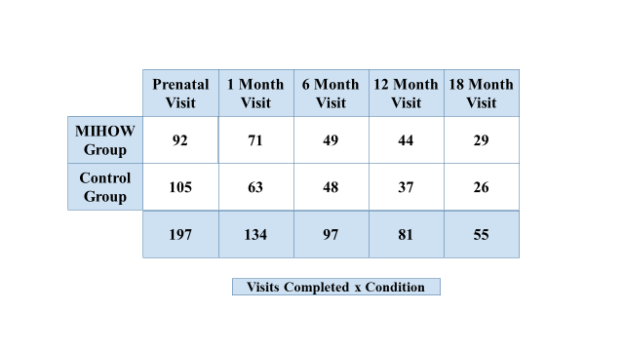

Tables 2 and 3 below present the data concerning number of data collection visits broken down by research site. It is clear that there was increasing difficulty with successfully scheduling visits through the several time periods, with particular loss of contact experienced with the control group at ABLE Families.
Table 2. Data Collection Visits: ABLE Families
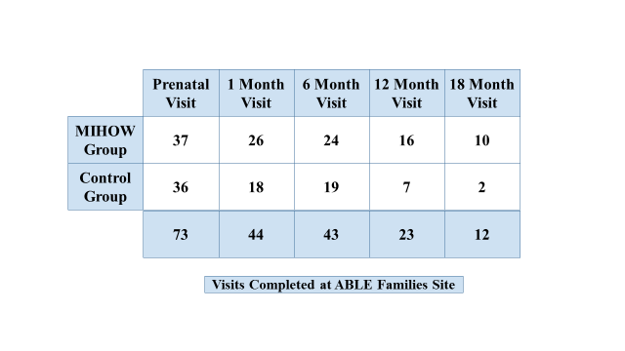
Table 3. Data Collection Visits: New River
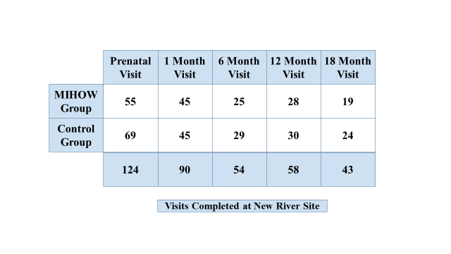

Tables 4-8 below present attrition related data broken down by site and/or by condition. In each table, the percentages noted in the cell reflect the proportion of participants remaining in the study at the specified time period. It is evident that attrition steadily increased through the study period. It is worth noting that due to our extended time frame for enrolling participants, our 18 month data collection period was not complete as of the cut-off data for the analyses reported here. Data from approximately 20 women are not reflected in these tables; this will be collected through mid-January, and updated results reported in the addendum we will submit in the spring.
Table 4. Retention: Percent of Remaining Participants at Each Data Collection Point
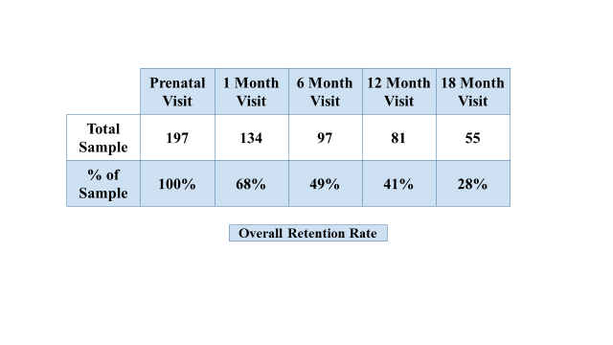
Table 5. Retention: Percent of Remaining Participants by Condition at Data Collection Points
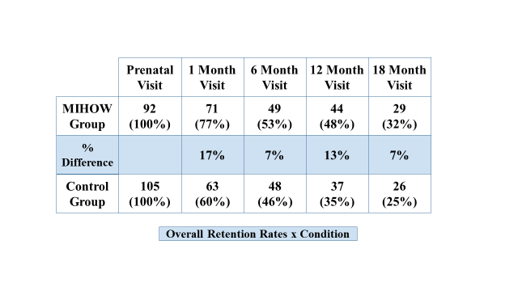
Table 6 below reveals that attrition at the ABLE Families site became more acute after the 6 month data collection period. Table 7 shows that attrition in the ABLE control group became particularly problematic, whereas Table 8 suggests that attrition at the New River site remained more evenly balanced between the two groups throughout the study.

Table 6. Retention: Remaining Participants by Site at Data Collection Points
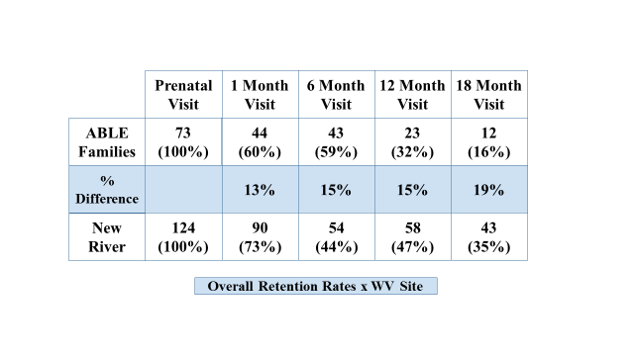
Table 7: Retention: Remaining Participants by Condition: ABLE Families Site
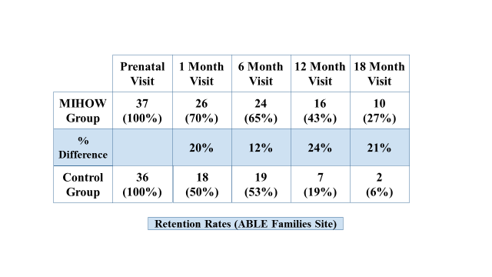
Table 8. Retention: Remaining Participants by Condition: New River Families Site
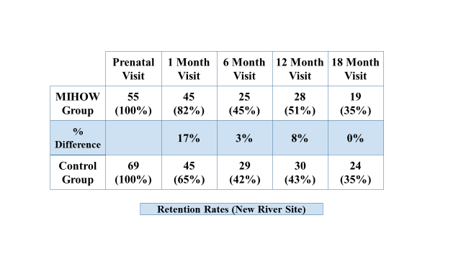

Demographic characteristics of participants and success of randomization
Tables 9a and 9b below provide data on demographic characteristics of total participant group at the outset of the study. As Table 9a reveals, the group was predominantly white; a majority was unemployed and had no more than a high school education. A majority was covered by Medicaid for health benefits, and about two thirds of the group report monthly incomes of $2000 or less. Interestingly, most report living in “stable” rather than temporary housing. In contrast, home visitors and our data collection staff reported that unstable living conditions and frequent movement from one living location to another was a significant problem in terms of keeping up with participants. It is difficult to explain this inconsistency. One possibility is that the wording of the question was not clear; for example, “temporary” may have meant something like a “shelter” to participants who were living in family homes, even if they moved between multiple sites during the course of the study. Table 9b shows that most report having access to transportation and to the internet, few receive TANF, Disability Benefits, workers compensation, unemployment or child support. Somewhat fewer than half of the group receive food stamps.
Table 9a:
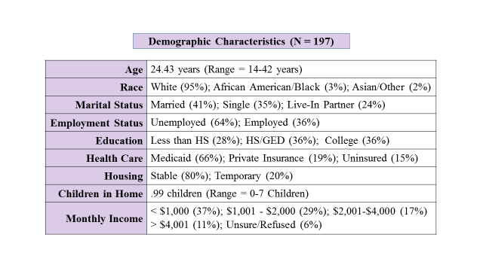
Table 9b:
.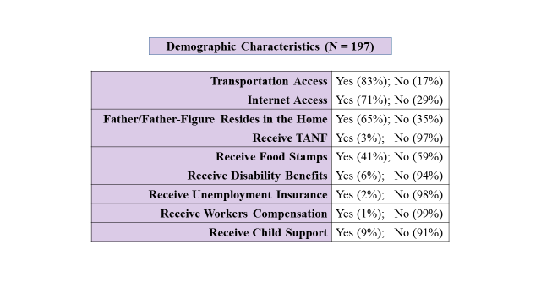
All demographic data were collected at the initial data collection point. There were no significant differences between the treatment and control groups on any of our demographic characteristics, and thus we are confident that our randomization process worked effectively, resulting in groups that were equivalent for purposes of the RCT.
We know that attrition raises questions about the equivalence of remaining groups- i.e. does attrition compromise the randomization such that the remaining groups are no longer equivalent, at least in terms of the demographic dimensions used to initially confirm equivalence. To check for that, we analyzed the groups of remaining participants at each of our data points, and found that the groups were still equivalent, with these exceptions: at the 6 month data collection, control group mothers were somewhat more likely to have reported receiving disability benefits (p =.03) at the initial, prenatal data collection visit, and at the 12 month reporting period, MIHOW mothers were more likely to have reported receiving child support during the initial prenatal data collection period (p =.027). There were no differences between treatment and control groups on any of the other demographic variables at the several data collection points. Thus, though it is possible that the remaining groups differ on variables not assessed, we have some confidence that the randomization retains integrity even within the attrition impacted groups that remained at each data collection point.
Though not specifically tied to demographic data, two other differences were noted in comparing the groups remaining at each data collection time period. One had to do with smoking: at the one month time period. The remaining MIHOW mothers had, more frequently than controls, indicated at the initial prenatal data collection point that there was someone smoking inside the home during the prenatal period (p.= .047), and that their “rules” for smoking allowed for smoking in “some rooms” or “anywhere” during the prenatal period. The second had to do with mothers’ perceptions of their own mental health at the time of enrollment. The remaining MIHOW mothers at the one month data collection period were more likely (p= .045) than controls to have said that their mental or emotional health was only “good” or “fair,” and less likely to endorse “excellent” than their control group peers. Thus, although our randomization process was quite successful in creating initially equal groups, it appears that attrition during the course of the study led to the groups remaining at the one month data period having differed at the study’s initiation on items associated with two of the outcomes of interest in the evaluation- smoking and emotional well-being. Both of these “pre-test” issues regarding smoking and emotional well- being will be discussed in the relevant sections of the report below.

RCT Outcome Variables

Birth Weight
Table 10 below compares the two treatment groups on mean birthweight (in pounds) of live births by condition. There was no significant difference between the groups in terms of average birthweight. Data in Table 10 were reported by mothers to the data collectors through the questionnaire developed by MIHOW and utilized within our study. In comparison, the data in later tables came from WV’s state data system and was provided to us by the OCMFH.
Table 10. Mean Birth Weight by Condition
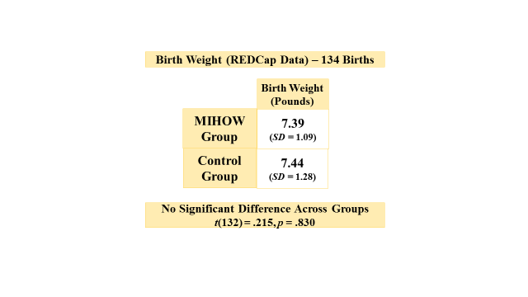
The WV Birth Score Form (developed and utilized by the state Department of Health and Human Services to record birth related data) reports birth weight data in categories as shown in Table 11 below. As is evident in the table, there were no significant differences between the two groups in terms of birth weight categories.
Table 11: Birth Weight within Categories by Condition
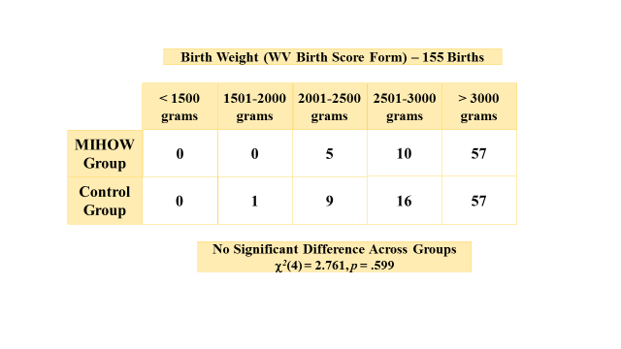
To examine the possibility of differences between the groups on the more global measure of high versus low risk births, we collapsed categories and compared the groups in terms of births above and below 2500 grams; again, there was no significant difference found between the two groups. However, we noted here that there was a percentage difference between the two groups such that 7% of the MIHOW births, and 12% of the control births were low birth weight (LBW). Though not statistically significant within the confines of our small number of participants, and the overall relatively low frequency of LBW births in the general population, when these data are examined a bit more carefully, there are suggestions of positive contributions from the MIHOW program towards decreased frequency of LBW births. This perspective is explored more fully in the “discussion of results” section below.

Table 12. Birthweight in Categories by Condition: Collapsed Categories
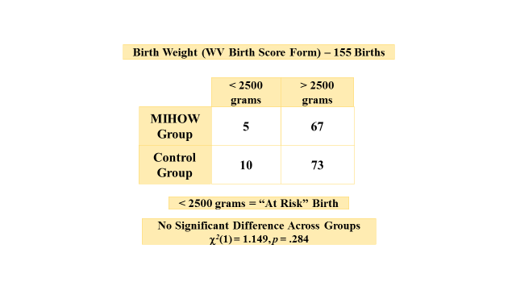

Breastfeeding
Encouragement and education about the benefits and best practices concerning breastfeeding is a focus of the MIHOW program. We assessed participants’ plans for breastfeeding at the first (enrollment in the RCT) data collection meeting, as well as their actual behavior after the birth.
As expected for our equivalent groups prior to treatment, there were no significant differences between them at the outset of the study in terms of their plans for breastfeeding. Table 15 below shows that there were no significant differences the time of enrollment in the study in terms of overall plans to breastfeed, or – for those who did plan to utilize breastfeeding – how exclusively they intended to breastfeed. However, Table 16 provides data collected at the time of the babies’ birth, and results still show no significant difference between the groups in terms of plans to breastfeed. We note that Table 15 presents data collected by our data collectors at the time of enrollment in the study utilizing the MIHOW questionnaire, whereas Table 16 reports data collected through the WV Birth Score system at the time of the babies’ birth, and thus after the treatment group women had been participating in MIHOW for some, though clearly varied, periods of time. Note that in Table 15 and several others below, the source of data is labeled as “REDCap Data”- this refers to data that came from the self-report questionnaire developed by MIHOW and utilized in this study, as compared to the WV Birth Score data, which was collected at hospitals by health care workers at the time of the babies’ birth.
Table 15. Pre-Natal Plans for Breastfeeding by Condition
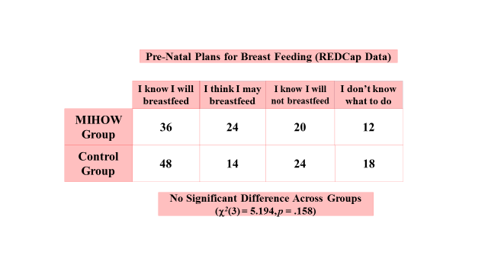

Table 16. Plans for Breastfeeding at Time of Birth
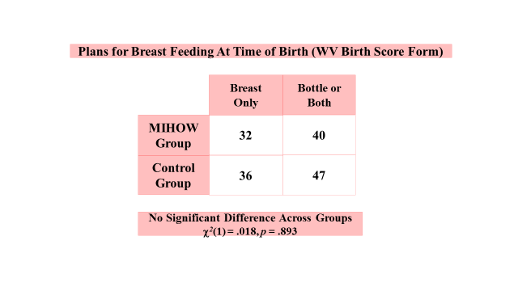

We then examined the participants’ reports concerning utilization of breast feeding after the birth of their babies. As can be seen Table 17 below, at the one-month post birth data collection visit, there was no signficant difference between the groups in response to the question “Did you ever breastfeed or pump?” However, in response to the question “Are you currently breastfeeding?” there was a trend (p<.08) for MIHOW/treatment group mothers to be currently breastfeeding more requently than control group mothers, but this trend did not reach the p<.05 level needed to be classified as statistically significant. The possible effect of small sample size on this result is discussed in a later section of the report.

Table 17. Breastfeeding Behavior by Condition
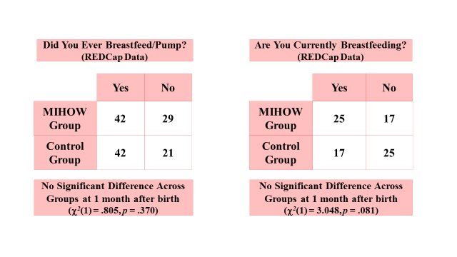
Looking at breastfeeding at bit more fully, the subgroup who had breastfed but were no longer breastfeeding were asked at the one month data collection period “How old was your baby when she/he completely stopped breastfeeding?” Results showed no differences between the groups, as shown in Table 18 below:
Table 18. Age at Cessation of Breastfeeding by Condition
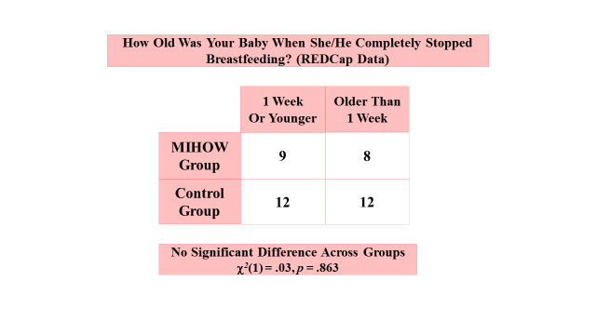

Mothers who had attempted or made ongoing use of breastfeeding were asked, “How old was your baby when she/he was first fed formula?” As can be seen in Table 19 below, there was again no significant difference between the groups in their responses to this question.

Table 19. Age at First Breastfeeding by Condition
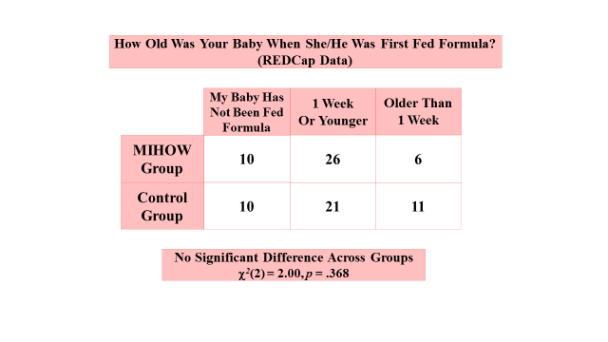

Smoking
Smoking data were collected via self-report first at the enrollment data visit, and then again at the one-month post birth visit. Additional data concerning nicotine use was collected through the WV Birth Score form.
As can be seen in the Table 20 below, at the enrollment time period, the groups did not differ in their reported smoking frequency; at the one month post birth visit, there was a clear, but still non-significant trend for observed differences between the groups, which appeared to be accounted for primarily by quite a few more treatment group members reporting that they were not smoking “at all” as compared to those in the control group. Because decreased smoking is an important goal of the MIHOW program, and because our sample size is relatively small, we decided that it was appropriate to look more carefully at these data by collapsing the three categories into two, reflecting those participants who reported smoking “every day/somedays” or “not at all.” As shown in Table 21 below, this 2 x2 analysis demonstrated that MIHOW mothers were significantly more likely to report they were not smoking “at all” at the one month data collection point.
Table 20. Current Smoking Behavior by Condition
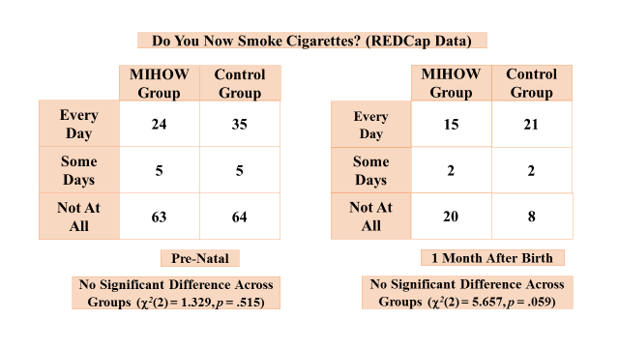
Table 21. Current Smoking Behavior by Condition: Collapsed Cells
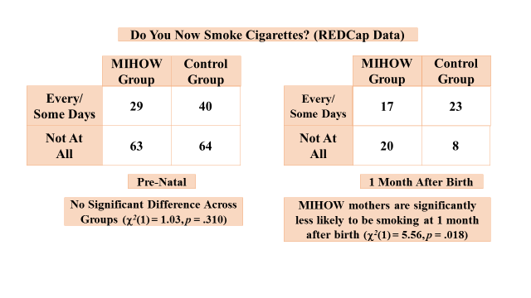
Participants also were asked about smoking behavior by others in their homes. As Table 22 below shows, at the enrollment data collection visit, there was no difference between the groups, and the data from both groups indicate that 30-35% of their homes included a smoker. At the one month post birth visit, the proportion of participants in either group that reported a smoker in their home had gone down quite a bit, but more dramatically so in the control group, such that treatment group participants were more likely to report a smoker in the home than were control group participants. It is important to remember here that earlier we noted that in spite of our successful randomization effort, attrition changed the makeup of the remaining groups such that the groups remaining at this data point differed in terms of smoking in the home by others at the initial, pre-intervention enrollment time period. MIIHOW mothers still in the study at one month had reported more smoking in the home by others back at the enrollment period. In other words, the significant difference between groups seen in Table 22 is most likely explained by the differences in smoking by others in the home that was evident, in spite of randomization, prior to initiation of the study. More exploration of these data is provided in the discussion section below
Table 22. Smoking by Others in the Home by Condition and by Data Collection Point
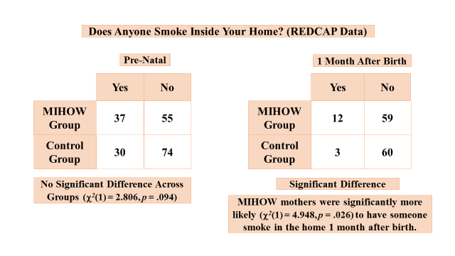

We also examined data concerning “rules” that the participants had about smoking in their homes. In discussing this question we note that the mean age of these participants is 24, with the age range going as low as 14; many of them still live in homes with their parents/guardians or other circumstances where they may have little leverage as far as establishing real “rules” for the household. Thus, we encourage the reader to interpret data from Table 23 with particular caution. The table shows no significant differences between the groups at either data collection period; participants in both groups claimed more stringent “no smoking” rules at the one month post birth period (e.g. no one endorsed allowing smoking “anywhere.”) It is important, too, to remember that as discussed in the earlier section on attrition, the remaining participants differed on this item back at the enrollment period, such that MIHOW participants had “rules” in their homes allowing smoking in more places than did the control group. Thus, the current data showing no difference between them regarding “rules” for smoking in the home might be seen as indirect support for MIHOW encouragement of their participants to establish more stringent rules for smoking, in that they appear to have moved from a situation where they allowed smoking in the home more freely prior to the study’s initiation to having eliminated that differential.

Table 23. Rules Regarding Smoking in the Home by Condition
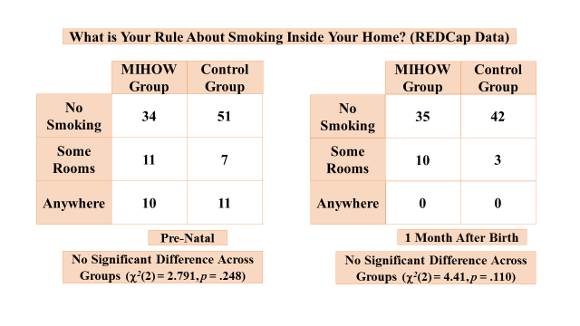

Post-Partum Depression
As noted earlier, to assess participants’ levels of post-partum depression, we utilized the Edinburgh Post-Natal Depression Scale at both the one month and six month post birth data collections. Though not an exact “pre-test” of this same construct, we do have a less psychometrically sophisticated measure of participants’ emotional well-being at the inception of the study. One item on the self-report questionnaire developed by MIHOW that we adopted for this study is a question concerning the participant’s perception of her own “emotional health.” As the table below shows, there was no significant difference revealed between the two groups on responses to this question, though it may be worth noting that there is a trend (p=.075) suggesting that the MIHOW group – in spite of the otherwise quite successful randomization process - perceived their emotional health to be somewhat poorer than the control group from the outset of the study, with proportionately fewer women in the excellent/very good categories and proportionately more in the fair/poor categories. Further, as noted in the discussion of attrition above, attrition apparently impacted the groups of women remaining at the one month time period such that the trend noted between the full groups at the initiation of the study became a significant difference between them at the evaluation’s outset when only the women remaining at the one month time period are included in the analysis. Thus, it appears that the trend towards somewhat poorer perceptions by MIHOW mothers of their own emotional well-being at the one month time period is explained by the pre-existing difference between the groups from whom one month data were collected that existed at the outset of the study.

Table 24. Perception of Emotional Well-Being (Prenatal)
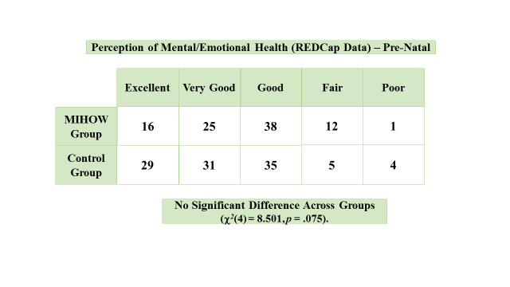
At the one month post birth data point, Table 25 below shows that responses to the same question are again not significantly different, with the higher “p” value indicating that the scores were more similar than at the preliminary assessment point.
Table 25. Perception of Emotional Well-Being (One Month Post Birth)
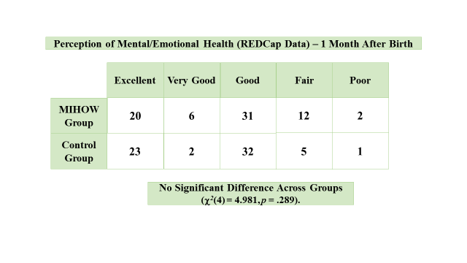
Two other questions from the self-report questionnaire developed by MIHOW administered at one month post birth are related to the emotional health/maternal depression domain. As shown in Tables 26 and 27 below, a question exploring frequency of experiencing interest/pleasure in activities showed no difference between the groups, whereas a question concerning frequency of feeling “down, depressed or hopeless” revealed that treatment group women were significantly more likely (p.< .011) to endorse “sometimes” feeling that way than were control group women. We would be quite cautious in interpreting the latter result as there may be a variety of reasons that the treatment group mothers would be more likely to acknowledge “sometimes” having those experiences that would not suggest that the MIHOW program itself “causes” more frequent negative experiences for participants. First, as discussed above, the MIHOW mothers remaining in the one month collection period were found to see themselves as experiencing somewhat less emotional well-being at the outset of the study, which may explain this result. Further, the MIHOW program, in attempting to prepare mothers-to-be for the experiences of childbirth and early parenting, is likely to have normalized the stressors and related feelings involved with this challenging period, and thus given their participants a kind of “permission” to recognize and acknowledge “sometimes” feeling down and/or depressed as part of the normal range of post-partum experiences.
Table 26. Post Birth Interest/Pleasure in Activities and Feelings of Depression by Condition

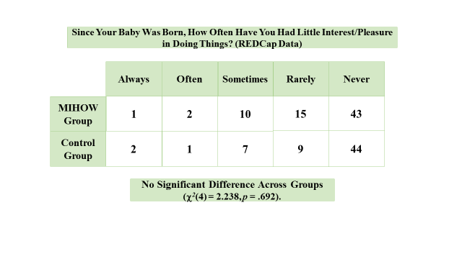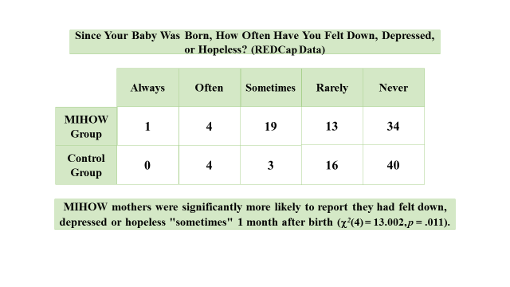
Table 27 presents data from the one month post birth data collection on the Edinburgh scale. On this scale, scores can range from 0-30; while there is no absolute cutoff for scores indicating that a woman is “depressed,” scores of 13 or higher are frequently used as indicators of clinical concern. The table reveals that there was no significant difference between groups on the percentage of women with scores over 13, though there was a slight trend (p<.1) for more treatment group mothers to have scores in the high range. There was a significant difference (p< .03) in mean scores on the scale, with the treatment group having a higher mean than the control group, although it is important to restate that the means for both groups are well below the scores reflecting clinical concern. Given that the pre-treatment data noted above showed a trend for treatment group mothers to see their emotional health as somewhat poorer at the outset of the study, and the attrition related result discussed above showing that the MIHOW mothers remaining in the study at one-month had endorsed items indicating somewhat less positive emotional well-being at the study’s outset, we would urge caution in interpreting this table, and we would not attribute a causal relationship between the treatment program and any increased tendency towards greater post-partum depressive experiences without more extensive research. On the other hand, the current data do not support our hypothesis that participation in the treatment group would result in less post-partum depression than experienced by control group mothers.
Table 27. Scores on the Edinburgh Post-Natal Depression Scale
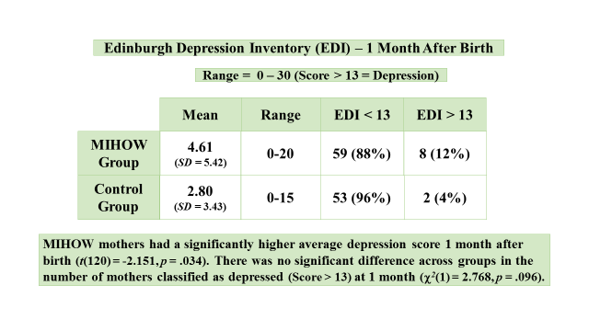
As mentioned earlier, we also assessed post-partum depression at the six month data point using the Edinburgh scale. As shown in Table 28 below, at the six month time period scores from the two groups were not significantly different, with mean scores being both quite low (2.69, 2.86 within the 0-30 possible range) and revealing no significant difference in proportion of women scoring above the clinically significant score of 13.
Table 28. Scores on Edinburgh Post-Natal Depression Scale (6 months)
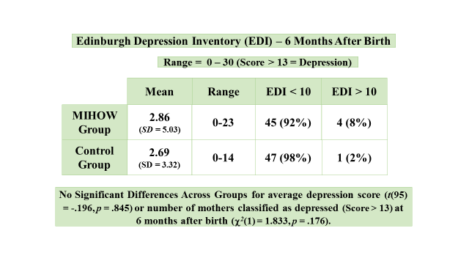

Home Environment

Based on MIHOW’s program goals, one of our hypotheses was that the home environments of treatment group participants would demonstrate more elements of what is considered appropriate for optimal infant/toddler development. Our measure for this domain was the HOME Inventory, which provides total scores as well as scores on the six subscales identified in Table 29 below. Data were collected at the one year post birth data point. As Table 29 shows, there were no statistically significant differences between the groups on total scores or on any of the subscales.

Table 29. Scores on the HOME Inventory by Condition
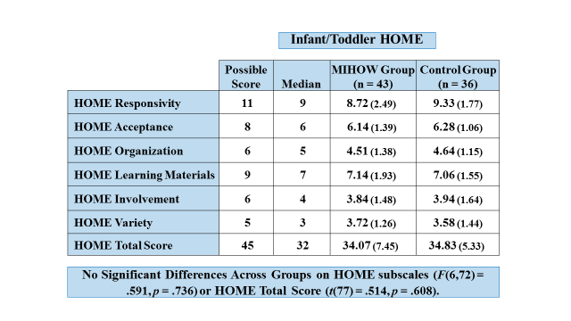

Knowledge of Infant Development
Another goal of the MIHOW program is to improve new mothers’ breadth and depth of knowledge about a wide range of information associated with infant development. To assess this domain, we used the Knowledge of Infant Development Inventory (KIDI), which provides both a total score and scores on the six subscales identified in Table 30 below. The table shows that at the one year post birth data collection time, there were no significant differences in means between the two groups on total scores or on any of the subscales.
Table 30. Knowledge of Infant Development Inventory Scores by Condition
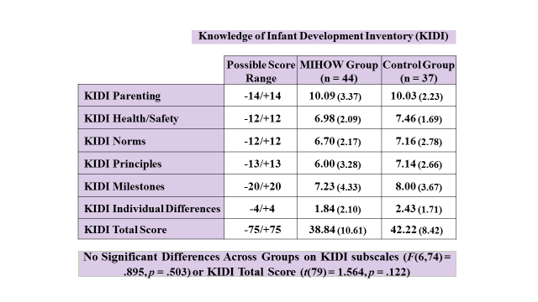

The data we provide below for the last two variables in this report (parenting stress and utilization of community resources) should be looked at as preliminary; the data were collected at the final, eighteen month data collection point; quite a few women had yet to be visited for that final visit as of the required cutoff date for completing this report. Thus, the number of women included in these analyses—already diminished due to attrition issues discussed earlier—is made even smaller by exclusion of those not yet visited. A more complete presentation of these data will be included in the addendum to this report that will be submitted in Spring, 2016.

Parenting Stress
As can be seen Table 31 below, within the small sample available as of our cutoff date for the 18 month data collection time period, there were no significant differences between treatment and control group participants on the Parenting Stress Index (PSI). The “no difference” finding held for total scores as well as for the subscales.

Table 31 Parenting Stress Inventory Scores by Condition
.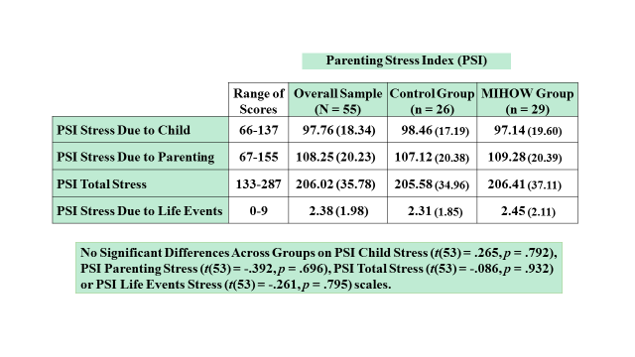
Connections to Community Resources
One of the goals of MIHOW is to connect mothers with supports and resources of all types that they have available to them within their communities. Thus, the last dimension to be examined in this section is the degree to which mothers in the two groups may have differed in how frequently they accessed available community resources. As mentioned earlier, to assess this dimension we created two simple checklists of community resources—one for each research site. The lists were based on resources in the two communities that MIHOW staff generated for us—sites that they would be likely to refer their MIHOW clients or in some other way recommend that they access or educate them about. Participants were asked to simply indicate on the form whether they had or had not accessed or made use of that resource during the timeframe of involvement with the research project. Though not a psychometrically sophisticated instrument, we considered it an acceptably face valid method to gauge potential differences between the groups in frequency of accessing or utilizing these community resources. Again, we note the caution needed for interpretation of these data, given the small sample included so far in the 18 month time period.
The sets of tables immediately below are site specific; the first set of two (Tables 32a and b) is for ABLE Families, while the second set (Table 33 a and b) is for New River. The data in in each set show the number of participants from each group who indicate having made use of that specific resource. As can be seen in these tables, within the very small number of participants reporting (particularly at the ABLE site) there is no clear difference in the pattern of usage or the mean number of resources accessed between treatment and control groups. It is particularly difficult to draw conclusions about participants at the ABLE site, where so far there are only two control group members represented in the tables—clearly not enough to draw generalizable conclusions.
Table 32. ABLE FAMILIES: Community Resource Utilization
Table 32a.
Table 32 b.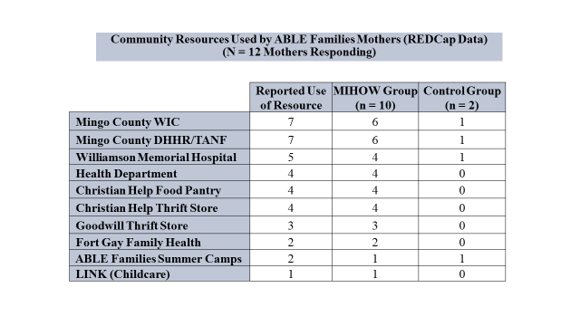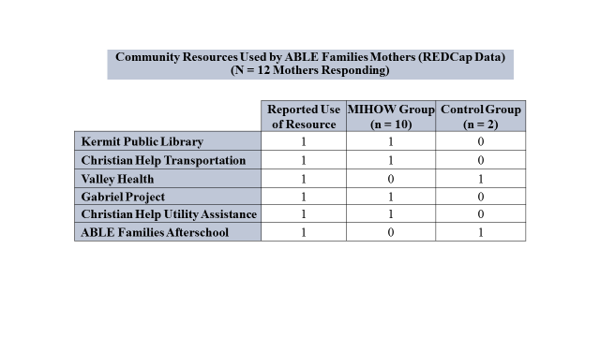

Table 33. New River: Community Resources Accessed
Table 33a
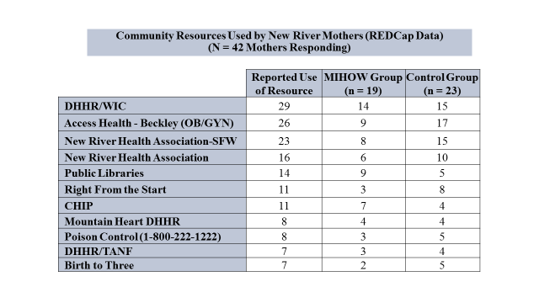
Table 33b
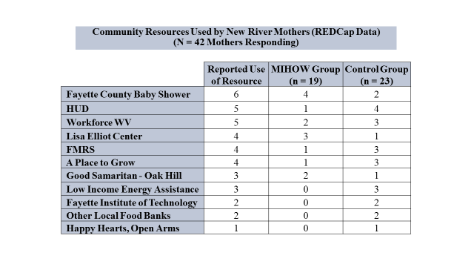
Table 34 shows the results of simple t-tests between treatment and control group members for all participants who have reported data as of our cutoff date, comparing the groups in terms of the mean number of resources accessed. Table 35 shows the results for ABLE Families and New River separately; As mentioned in the section on the parenting stress data, a more complete presentation of the data for this variable will be included in the addendum to be submitted this spring. For the limited participant pool available for these analyses, there is no evidence of significant differences between groups in utilization of community resources.
Table 34. Mean Scores: Number of Community Resources Utilized by Condition (Sites Combined)
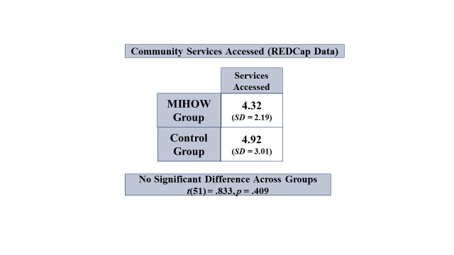

Table 35. Mean Scores: Number of Community Resources Utilized by Site and Condition

Able Families New River
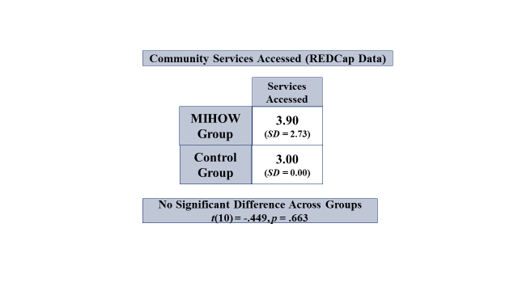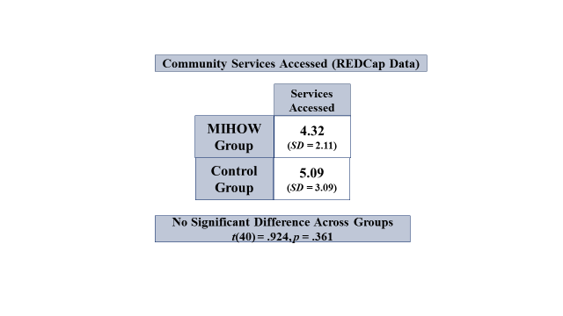
Other Variables to be Studied: Dosage and Alliance
As discussed earlier, it is plausible that two additional variables tied to the interaction between participants and home visitors may have had an influence on the outcome variables. More specifically, it is possible that within the treatment group, there is variability in outcomes associated with “dosage,” or frequency of contacts between MIHOW group participants and home visitors, and with the “alliance,” or quality of relationship developed between the MIHOW participants and their home visitors. We will present and discuss analyses of these data in the addendum to this report, which will be submitted later this spring.

Discussion of Results
The MIHOW evaluation research discussed in this report extended through a significant time period, across two sites in rural, underserved and impoverished counties of West Virginia. The agencies that house MIHOW at the two sites are quite different from one another, yet both sites experienced significant stressors associated with participation in the RCT itself. Recruitment and retention of participants in the research was difficult and resulted in smaller numbers of participants across all time periods than had been expected, with some data still to be collected as of the writing of this report. All this to say that the evaluation was quite challenging, and thus it should not be surprising that at the conclusion of the project our results are mixed. Both qualitative and quantitative results revealed promising dimensions that appear to be substantive and demonstrable strengths of MIHOW, as well as disappointments in the sense that hypothesized benefits of MIHOW failed to be supported in our data. In the following paragraphs, we summarize what we see as the key findings, discuss various possible explanations for them, and suggest several areas for program development as well as future research into program effectiveness.
It seems clear from the qualitative data presented and discussed earlier that mothers truly valued their experiences in MIHOW and particularly valued their relationships with their home visitors. In a parallel manner, the home visitors and other MIHOW staff were genuinely proud of the program and seemed truly dedicated to its mission and success. Key themes identified through qualitative methods indicated that participants felt strongly supported by their visitors, and perhaps more importantly, they experienced strengthening of their confidence and ability as mothers and as women more generally—and for many this translated into greater levels of activity in and engagement with their communities. In other words, there was evidence that the “strengths-based approach,” which is a central part of MIHOW’s operating philosophy, is effectively communicated through MIHOW staff training and then operationalized by home visitors in a manner that is ultimately experienced by mothers in a manner that positively influences their attitudes and behaviors as new mothers.
There is also qualitative evidence that the MIHOW program’s prioritization of knowledge about infant development is impactful in terms of the mothers’ recognition of and attention to material presented and discussed by home visitors. In particular, mothers made quite frequent spontaneous references to how they made use of the “Ages and Stages Questionnaire” and other checklist type information to help them assess how they and their babies were progressing. This suggests that program participants were eager and able to learn and make use of material that MIHOW provided and prioritized within the context of sustained relationships with home visitors.
Not surprisingly, the qualitative data also demonstrate that the mothers in the program experience a variety of stressors and challenges that MIHOW cannot fully address. Transportation problems, limited material resources, isolation, lack of work—all of these are beyond the programmatic range of MIHOW; adding to these social/environmental challenges are the limits on frequency of home visits necessitated by budget and personnel constraints and it is clear that both program participants and MIHOW staff recognize and feel stressed by the array of unmet needs the mothers face daily.
The RCT was guided by several hypotheses based on specific goals of the MIHOW program. Data presented above reveal a mixed picture of results. Discussion and interpretation of these results have to be considered in the context of the smaller than expected number that was ultimately enrolled in the study—a problem which was compounded by the steady attrition observed throughout. Attrition was clearly a significant factor in terms of decreasing the overall number of participants available for data collection. Not only did attrition ultimately result in many fewer participants (and thus to less power associated with statistical analyses); in principle, this attrition could, in some cases, have resulted in data that were no longer representative of the originally well randomized groups. This latter concern is somewhat mitigated by our analyses reported earlier revealing that there were only minimal differences between the attrition-reduced groups and the original groups on the demographic variables used to confirm the original randomization. However, we cannot say how those who left the study might differ from those who remained on other variables, such as “conscientiousness” or “persistence” or the number of crises they encounter, or health variables, or other potentially important dimensions. The most striking attrition impact revealed in our tables is in the control group at ABLE Families, which resulted in a decrease down to 19% and 6% of ABLE control participants at the 12 month and 18 month data collection periods, respectively—numbers which raise legitimate concerns about the representativeness of that group.
In terms of the specific outcome variables studied in the RCT, results seem most promising in terms of smoking and breast feeding and—to a lesser extent—perhaps birthweight. On the other hand, our data clearly did not support hypotheses regarding MIHOW participants demonstrating lesser maternal post-partum depression, greater knowledge of infant development, having home environments better suited to infant development, experiencing lessened stress associated with parenting or demonstrating more frequent utilization of community resources. Our measures for these latter variables revealed no significant differences between the treatment and control groups, and for several, the mean scores were close to identical. After a brief discussion of the results which might be seen as supportive and/or promising for MIHOW, we will return to discussion of the negative results.
The only statistically significant differences between groups were demonstrated in the tables concerning smoking. The encouraging outcome for MIHOW emerges from the data on current smoking behavior. In that table, MIHOW mothers were shown to be more likely than their control group peers to be smoking “not at all.” This is clearly a positive indicator for MIHOW, given the importance of smoking for both mothers’ and babies’ health. Given that these data were collected at the one month data collection, the attrition problem had not yet maximized, and thus we have somewhat more confidence in the validity of that finding than we might for results obtained later when the n and the associated percentage of original enrollees remaining in the study were much smaller. Tempering that result somewhat are two issues. First, the significant outcome was obtained after collapsing the original categories from three to two; while we believe this is fully justified, given the small numbers involved in the table, we want to acknowledge that what was a promising “trend” in the original table became a significant finding only after this collapsing of cells.
Second, and more substantively, the associated smoking related table showed that MIHOW mothers were more likely than control peers to have homes in which someone else was smoking. As noted earlier in the section on attrition, this latter result is likely an artifact of the finding that attrition by the first data collection point affected the remaining groups such that the treatment group had more smokers in their homes than did the control group from the outset of the study. However, even considering this explanation, there is no evidence that MIHOW had a significant impact that resulted in decreased smoking by others in the homes, though there was some indirect indication (elimination by the one month data collection point of the pre-test differential whereby remaining MIHOW mothers lived in homes with weaker smoking related rules than did control mothers) of a positive influence on the development of smoking rules that would decrease babies’ exposure to second hand smoke. Thus, these data taken together suggest that MIHOW mothers were themselves smoking less frequently than control mothers at one month post birth, but that their babies may be more frequently—though most likely equally, given the pre-test differential discussed above—exposed to second hand smoke as compared to controls.
One plausible explanation of the differential impact of MIHOW on the smoking behavior of mothers as compared to others in the home is that MIHOW is simply far more likely to have greatest impact on the participant herself, and far less on those who are in the woman’s home but not themselves directly participating in the program. Smoking is a very difficult behavioral pattern to influence, particularly with people who are not themselves intrinsically motivated to change their behavior. It is impressive to us that MIHOW mothers appear to be smoking less at one month post birth than were the controls; this result is clearly in line with an important, health related MIHOW goal. However, there was no similar benefit observed in the data connected to second hand smoke. We are sensitive to the difficulties that many of the young women in the program may have in influencing the people in their environments, given how infrequently people decrease or cease smoking due to direct persuasion efforts of others and how, for many of the MIHOW mothers, the other smokers in their homes may be older or more authoritative family members.
The breastfeeding data also revealed mixed results, with one promising trend. There were no differences between groups in terms of the expressed plans for breastfeeding at either the prenatal enrollment period or at the time of the baby’s birth. Neither was there a difference in the proportion of mothers who had “ever” breastfed. Among the women who had breastfed but were no longer doing so at the one month data collection point, there was no significant difference in the babies’ ages when breastfeeding was discontinued. However, at one month post birth, the MIHOW mothers were somewhat more likely than controls to still be breastfeeding. Though this result did not quite reach statistical significance ( p. < .08) this is almost certainly due to the small sample size, given that the numbers for each group are completely reversed in the table (MIHOW: 25 “yes”, 17 “no”; Control: 17 “yes”, 25 “no”); indeed, an earlier analysis of these data revealed a significant relationship between group and current breastfeeding. It was later discovered that one woman’s data had been inadvertently left out of that analysis; including her data was enough to shift the result from significant to non-significant, demonstrating the impact of having such a small sample on the analyses.
The overall breastfeeding data is thus mixed, though for perhaps the most important breastfeeding outcome—continuity of breastfeeding until at least one month—there was an indication of MIHOW having a positive influence on their program’s mothers. Explaining why the results were not more supportive of MIHOW’s efforts towards all aspects of increased breast feeding (e.g. why more MIHOW mothers did not intend to breastfeed at the time their babies were born, or why there was no difference among those who had stopped breastfeeding as to when their babies moved to exclusively formula feeding) is challenging, though the trend towards more MIHOW mothers still breast feeding at one month is certainly worth emphasizing. While we are certainly not experts on the substantive areas of MIHOW’s work, we note that the data showed no difference between groups at the time of the babies’ birth in terms of plans for breast feeding, though MIHOW mothers who do breastfeed at all are still doing so more frequently at one month post birth. This seems like an important issue for MIHOW senior staff at each site, as well as at Vanderbilt, to consider— i.e. given the centrality of breast feeding to MIHOW’s programmatic mission, what, if anything, might be done in terms of visitation frequency or home visitor focus within the visits during the time periods immediately leading up to the birth that might more strongly encourage and/or support planning to breastfeed while continuing to respect the mothers’ autonomy in making this very personal decision—a very delicate balance, indeed.
MIHOW’s program also hopes and intends to facilitate the birth of babies with healthy birthweights and decrease the frequency of low birth weight (LBW) babies. The data for this outcome goal are also mixed. The tables which present data on birthweight indicate no differences between groups in the proportions of babies in each of the birthweight categories. Given our small numbers, and the relatively low frequency of LBW births, this was not totally unexpected. However, looked at a different way, the MIHOW program may be having a more positive impact on the frequency of LBW than would be concluded from just examining those tables.
In West Virginia, the statewide percentage of LBW births is 9.4% as of the most recent data available (2012; data center.kidscount.org, 2016). It was 9.2% as of 2009, according to the 2012 WV State Health Profile, suggesting a relatively steady percentage in recent years. In Fayette County (home of the New River site, the LBW percentage was 9.5% in 2012, whereas in Mingo County (home of ABLE Families) it was 11.7% at the same time period. Of the 155 live births within our participant group, there were 15 LBW births, which is 10.3 percent LBW rate- slightly higher than the state average as of a few years back. However, in the MIHOW group, there were 5 LBW births out of 72 total, resulting in a 7% LBW rate, whereas the control group had 83 live births, with 10 of them LBW—a rate of 12 %. If the 12% rate in the control group is a valid indicator of the rate of LBW births within the population of young women represented by our research participants, then the 7% rate of LBW births in the MIHOW group represents a decrease of over 40% in the percentage of LBW births from the 12% in the non-treated, control research group. Looking at each site separately, the ABLE Families MIHOW group had just 1 LBW birth out of 26 total (4%), whereas there were 5 out of 34 (17%) in the control group. At New River, there were 4 LBW births out of 51 (8.5%) in the MIHOW group and 5 out of 59 in the control group (9.3%). The control group percentage of LBW is very close to the county rate from 2012 (9.5%). Though 8.5 % is not a huge absolute difference from 9.3%, it represents an approximately 8.5% decrease from the control group rate of LBW.
Clearly these results emerge from a small sample size and we don’t know how fully representative our participant groups are of the larger populations within their counties; thus, these data must be looked at cautiously. However, given that data from all three vantage points (total across sites as well as within each of the two sites separately) reveal the MIHOW group demonstrating lower percentages of LBW babies than did the control group, there is at least a plausible suggestion that something important may be going on related to this important outcome variable. If it were to emerge from additional research that MIHOW groups reliably experienced decreases in LBW births on the order of 20% (which is a lower figure than that which emerged from our combined group results), then those differences might be seen as representing an important outcome in terms of contributions to decreasing the long term costs (financial, familial, and social) associated with LBW births.
Results from the other variables assessed within the RCT are clearly more disappointing in terms of MIHOW’s programmatic goals and focus. There were no significant differences between treatment and control groups (or trends in that direction) for the hypothesized benefits of MIHOW regarding post- partum depression, knowledge of infant development, developmentally appropriate home environments, parenting stress, or utilization of community resources (thought the latter two findings are based on incomplete data which will be finalized in the addendum discussed earlier).
There are several possible explanations for the apparent lack of MIHOW impact on these variables. The first that must be considered is that MIHOW simply does not have measureable effects on these aspects of parenting infants, at least within populations that are represented by our participant groups. Certainly, the data in this study do not suggest that significant differences would be found on these variables in follow up studies that were conducted in a similar fashion with the same assessment measures. We recognize too that our relatively small sample size—quite a bit smaller than the original target of 400 participants—reduces the power of our analyses and makes it more difficult to produce statistically significant results; however, for several of the variables of interest, the differences between treatment and control groups were so small that it is unlikely that an increased number of participants would have revealed significant differences in the hypothesized direction. We will, however, continue to collect the last of our 18 month data and present updated analyses within the addendum to be submitted in the spring.
The primary exception to this subdued expectation about the likely contribution of a larger number of participants is the breastfeeding data, wherein it is quite likely, as discussed above, that a larger group of participants would have revealed a significant difference between the groups such that more MIHOW mothers would likely have still been breastfeeding at one month. This is not a minor issue, in that if we had found significant differences between the groups on these two variables (smoking by mothers and extended breastfeeding) that would have reached an important criterion for HomVEE study evaluations (two significant findings in support of the program’s impact), particularly because these were variables assessed early enough in the study that attrition had not reached the problematic level that emerged for later time periods.
We also considered other possible contributors to the non-significant findings, given how clearly senior MIHOW staff at Vanderbilt and our study sites believed at the outset that, given MIHOW’s mission and practices, these were appropriate target variables. Though we used well established measures for these variables (except for the community resource dimension), it is possible that different measures, or different ways of assessing key variables might reveal different results. Consider, for example, the area of “knowledge of child development.” The qualitative data reveal that the subset of treatment mothers studied in this group rather consistently and spontaneously, throughout the entire time period of the evaluation, talked about how much they had learned from their home visitors about developmental milestones, about reading to their babies, etc. In other words, learning and having useable new knowledge was a significant theme in the qualitative data. Since there was no parallel set of qualitative data from the control group mothers, we can’t compare them; however, the data we do have suggest that the MIHOW mothers were or became sensitive to the importance of new learning that they could utilize “right now” as they interacted with their babies—and this may not be the kind of learning and knowledge that is assessed through the KIDI. Further, another of the themes that emerged in the qualitative data was the “customized” nature of the program. Seen by participants and staff as a strength of the program, MIHOW is flexible in its implementation. Though there is a clear curriculum, the home visitors balance the delivery of that curriculum with their sensitivity to the ongoing dynamic quality of their participants’ lives and they make it a priority to adapt home visits to the current challenges and needs of the women they visit. While this flexibility is an important expression of the program’s goals and values, may strengthen the bonds between visitors and mothers, and may genuinely help the young women learn important skills and information to help them cope with their immediate needs and challenges, it may work against helping them, as a group, learn the “standard” curriculum material that would be assessed by an instrument such as the KIDI.
The home environment variable is also complex. Many of the participants in this study do not live in stable environments and/or may be living in housing not their own—e.g. with parents, other families, friends, etc.—and as noted earlier, frequent anecdotal reports from home visitation staff and data collectors suggest they seem to move/relocate rather frequently. In such circumstances, it is quite possible that these mothers have little to no control over the physical environments in which they live; indeed they may well feel extremely vulnerable to dislocation and feel fortunate to have a place to stay at all, and thus be very reluctant to even attempt to influence their living environments—if they had the power to influence it even if they were inclined to try. The smoking data may be associated with this idea—the MIHOW mothers were more likely to not be smoking themselves (a behavioral dimension which they can control directly), whereas the results for smoking by others in the house and “rules about smoking” did not demonstrate a positive MIHOW impact. To the extent that MIHOW mothers live and try to care for their babies in unstable and truly challenging environments over which they may have little control, it is at least plausible that a focus on the environmental dimensions measured by the HOME is not the best approach for attempting to assess the impact of MIHOW’s attempts to constructively intervene in the lived environments of their program participants.
The variables in this study which produced quantitative results most in line with the hypothesized benefits of MIHOW were smoking, breastfeeding, and (perhaps) birthweight. What these have in common is that each has a clear physiological dimension to it, in the sense that each would be likely to have positive impacts on the physiological development and/or health status of the babies. Though we would be cautious about pushing this idea too far based on our data, it is possible that future studies of MIHOW’s impact might benefit from focusing more on the bio-developmental milestones and markers of the babies themselves, rather than the rest of the variables used in this study, which focused largely on the mothers and on more psychological constructs such as parenting stress and knowledge of developmentally important information. For example, we know that maternal smoking is frequently problematic for the development of infants and babies; since less smoking by the MIHOW mothers was the only clearly significant outcome found in this study, it would make sense to study more carefully the possibility that babies of MIHOW mothers have better outcomes on developmental variables tied to maternal smoking. Similarly, breastfeeding is associated with a variety of positive developmental outcomes. Since there was a clear trend (which, as discussed earlier, almost certainly would have been statistically significant with even a modest increase in our number of participants) for MIHOW mothers to more frequently be breastfeeding at one month after birth than were controls, it makes sense to consider studying potential differences in developmental outcomes in the babies that are considered associated with continuity of breastfeeding.
We also considered the possibility that our results were negatively impacted by turnover of our data collectors during the course of the study. At the ABLE Families site, our original data collector left her role after about 1.5 years; her replacement left after approximately one additional year. During the last time period of the study, the data collector working at the New River site, who had been consistently doing the work throughout the project, agreed to finish needed collection of data at both sites. This was possible because there were relatively few remaining participants who had not yet reached the final data collection point of 18 months. Our conclusion is that there is no reason to suspect that data collectors influenced the results of the RCT. All of the data from the New River site were collected by our long term data collector, who is a highly experienced professional; analyses of the variables being discussed showed no differences between the sites on the pattern of results obtained, suggesting that the specific person collecting the data did not contribute to any variability (or lack of variability) in the results.
As we mentioned earlier in this report, we remain interested in the potential impact on MIHOW outcomes of the dosage and relationship/alliance variables. Though not discussed in this report, it is worth noting that each of these may be important to understanding the results presented here. Although we did eliminate women who never received any MIHOW services from the treatment group for all of our analyses, the remaining women varied extensively in how regularly and how frequently they had visits from their home visitors throughout their time in the study. It is certainly plausible that women who had three or five visits differed in significant ways from those who had 13 or 15, and those differences may be associated with very different outcomes. It is also plausible that women who had more prenatal visits and/or enrolled earlier in their pregnancy may have had better outcomes—particularly on the variables assessed at the one month post birth time period.
The alliance variable will also be of interest to explore; since the program is so intensely interpersonal/relationship based in its delivery, it is plausible that women who form strong alliances with their visitors may have better outcomes, though it is also possible that strong alliances as measured by our alliance inventory may be more associated with participants liking or valuing the program than with demonstrating the learning or behavioral changes that the program hopes to promote. One very early “hint” of what may emerge in a more complete examination of the alliance variable is a finding from the small group that has completed it so far that MIHOW mothers scored highest on three questions that ask about feeling liked, respected, and appreciated by the home visitor—in other words, issues that focus on the emotional qualities of the relationship. Their scores are consistently lower (though not dramatically so) on items that explore their perceptions about goal setting and areas of potential change for the mom—in other words, questions about the substantive areas of program focus.
One last perspective on the relative lack of consistent differences between the groups has to do with the long term nature of MIHOW’s involvement with the communities in which our evaluation research was situated. Both ABLE Families and New River are serving small, relatively isolated communities and their MIHOW programs have been actively providing their programs in each for many years; further, in both sites, MIHOW does a variety of programming that reaches women and other community members beyond those enrolled as individuals. Given these circumstances, it is plausible that much of what MIHOW offers to their program participants has been at least partially “absorbed” by the surrounding communities. In other words, key programmatic goals and methods may have been, and continue to be, transmitted through informal, less programmatically structured methods than the typical individual enrollment in the program itself, and thus over the years of working in these communities, MIHOW may be having impacts well beyond individual program enrollees. To the extent that this “absorption” phenomenon and associated extra-programmatic community impact has occurred, it may have led to wider general knowledge and acceptance of MIHOW’s ideas and teachings within these small communities, and thus blur distinctions between treatment and control participants on the outcome variables of central interest to MIHOW.
Though these ideas are clearly speculative in nature, it is important to remember that local MIHOW staff frequently present or participate in programs that are accessible to their entire community. There are multiple ways in which this informal transmission might occur in small communities beyond formal program presentations—MIHOW program participants share knowledge with friends and family members while program staff talk with and potentially influence teachers, health care workers, social agency staff members and informal community leaders. Further, MIHOW operates within larger agencies in both communities; the New River Health Clinic is a key resource for women in that service area, and it would not be unlikely for MIHOW’s key ideas and methods to have influenced and ultimately overlap with the prenatal and postnatal care received by all women who come the clinic for pre-natal and pediatric health care. ABLE families is a significant community agency within its service area, providing many programs for the area, and again, it would not be surprising to learn that MIHOW visitors are involved in many of them, and thus have “audiences” for much of what MIHOW seeks to teach outside of the formal structure of the program. Thus, it is certainly plausible that many of MIHOW’s principles and much of its key information has been communicated extensively within and absorbed by the communities they serve. Interviews conducted by our qualitative researchers provided data that clarifies the extent of MIHOW’s reach into the communities they serve. One site director noted that parenting related events well beyond traditional home visits; they are open to other mothers and are led by home visitors at sites throughout their service communities:
Our parent/child groups are socializations/playgroups for children, a time for parents to connect with other parents of young children, and discussion about parenting issues. They include a light healthy lunch, usually a take-home craft that parents and children create together, and other activities such as seasonal activities, story time, field trips to local parks and libraries, blueberry picking, etc. Parent discussion happens naturally and is guided by the trained home visitor to ensure that information is accurate. The home visitor models positive interaction and encourages parent/child interaction.
A home visitor was passionate about the extensive community outreach programming they do:
……You meet other family members, and mostly in this rural area everybody knows everybody. And here I don’t see any unsafe things to go to… We do Mom’s Day Out. We do playgroups, and the playgroups consist of bringing the families in with children, letting them [get] to know one another. We also do activities. We do reading the book, and we do songs. We do rhymes. They play. Children learn through play. Getting other parents acquainted with other parents. And the Mom’s Day Out, it just happened. We just took six girls out … and got their hair washed and dried, and cut. They got an eye wax. They got dinner on us. We just had fun with those six parents.
At one of our study sites, we learned that MIHOW holds a pregnancy group once per month, during which home visitors provide food, discuss topics associated with pregnancy and respond to questions from mothers-to-be. Programs tied to child safety are offered to the community, as are frequent open invitation “play groups” offering facilitated discussions on varied topics. Home visitors work within a local drug treatment center to assist pregnant women struggling with substance issues, facilitate a parenting group within the local Women, Infant and Children (WIC) office, make presentations at health fairs, and hold group meetings within two county high schools to help expectant teens and teen mothers. Since we didn’t extensively explore the full range of MIHOW’s engagement with their service communities in this research, we would not be surprised to learn that over the years MIHOW has had even more community involvements than those noted above.
It is also worth recalling an issue discussed in the qualitative section of this report focused on “unmet needs.” Specifically, home visitors noted real concern with the RCT research design that left many of their community members—quite possibly neighbors, friends, and colleagues since MIHOW utilizes community women as home visitors—without access to the MIHOW program services to which they are so clearly committed. Though we emphasize that we have no evidence to support this speculation, it is certainly plausible that at least some home visitors reached out, or were responsive to, at least some of the control group women who had expressed real interest in MIHOW, and informally provided some degree of MIHOW-related assistance. Within small communities, such informal interaction is quite possibly more the norm than the exception. Given our small sample size, relatively small amounts of “leakage” such as this could influence outcome comparisons on key variables.
Of course, we are not in a position to directly study the potential contribution of these “absorption” or “leakage” phenomena to the relative lack of significant differences observed between treatment and control groups within the communities we studied, though it would be very interesting to have a gauge as to how much influence MIHOW’s work has had on the community beyond their identified program participants. To do such a study would likely require comparisons to other counties or other population groups with similar demographic profiles that have no access to MIHOW to see if they, as a “clean” control group, would be assessed as similar or different to our control group on the key variables of interest. That would certainly not be an RCT, but would be informative about the degree to which MIHOW’s long term presence in a community may impact it beyond the limits of those who actually enroll and participate in it. Alternatively, an RCT could, in principle, be run in a community new to MIHOW to see if different results emerge, but that would require a method to deliver the program in a completely new site, which could then provide a potentially more “pure” control group—though that would require a significant outlay of resources within a challenging economic environment.

